

**ABLE RETAIL SYSTEM**

**Point Of Sale**

**User Guide**

**Table of Contents**

1. Setting up Your Company file 5

1.1 Creating a Company file 5

1.2 Login 7

1.3 Setting up using existing Database 9

1.3.1 Default port 11

2. Setup Guide 12

2.1 Data Related Setup List 12

2.1.1 **Tax Codes** 12

2.1.2 **Currency** 13

2.1.3 Payment Methods 14

2.1.4 **Shipping Methods** 16

2.1.5 **Customers** 17

2.1.6 **Suppliers** 21

2.1.7 **Accounts Receivables Starting Balances** 22

2.1.8 **Categories Setup** 23

2.1.9 **Item List** 23

2.2 System Setup List 24

2.2.1 Data Information 24

2.2.2 Preferences 25

2.2.3 User Maintenance 27

2.3 Terminal Setup 30

3. Inventory 31

3.1 Category 31

3.2 Creating Items 32

3.3 Building Items 35

3.3.1 To build item manually 35

3.3.2 To define an auto-build item 35

3.3.3 To auto-build an item 36

3.4 Price Update 36

3.5 Price Tag 38

3.6 Stock Adjustments 38

3.7 Stocktake 38

4. Sales 39

4.1 Creating a customer profile 39

4.2 Entering Sales 41

4.3 Quick Sale 43

4.4 Restaurant Point of Sale 45

4.5 Receiving Payment 46

4.6 Changing Status of a Sale 47

4.6.1 To change a quote to an order or invoice 47

4.6.2 To change an order to invoice 48

4.7 Printing Payment Receipt 48

5. Purchases 50

5.1 Creating a supplier profile 50

5.2 Entering Purchases 52

5.3 Receive Items & Approve Purchase Order 53

6. Promotion & Loyalty 55

6.1 Creating Loyalty Member 55

6.2 Creating Promos 56

6.3 Points Exchange Rate 61

7. Transactions 61

7.1 Finding Transactions 61

7.1.1 Using Transaction Lookup 61

7.1.2 Using Sales Register 61

7.1.3 Using Purchase Register 62

7.1.4 Using Item Register 62

7.2 Changing or Deleting Transaction 62

7.2.1 Changing Transaction 62

7.2.2 Deleting Transaction 62

7.3 Reversing Transaction 62

7.4 Recurring Transaction 63

7.4.1 To create new recurring transaction 63

7.4.2 To use existing transaction as Recurring 63

7.4.3 Recording Recurring transaction 63

8. Reports 63

9. Sessions 64

9.1 Starting a Session 64

9.1.1 Starting a new session to create transactions. 64

9.1.2 Continuing existing session. 65

9.2 Ending a Session 65

9.3 Session Manager 66

10. Backup Database 67

10.1 Auto Backup Database Tool 68

11. SQL Restore DB 69

12. Company Profile Editor 70

13. Journal Export Tool 74

14. Kitchen Display 75

# Setting up Your Company file

When setting up company file, you record your company basic information to the system, such as company name, contact information.

## C**reating a Company file**

1. Start Able Accounting System

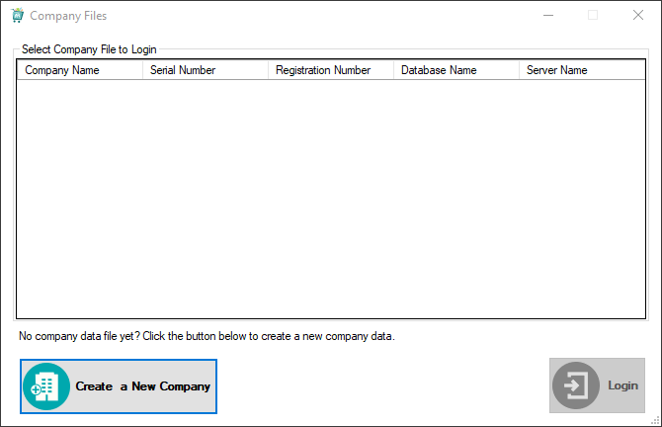

1. Click **Create a New Company.**
2. The Introduction tab of New Company File Assistant will be displayed then click **Next**.

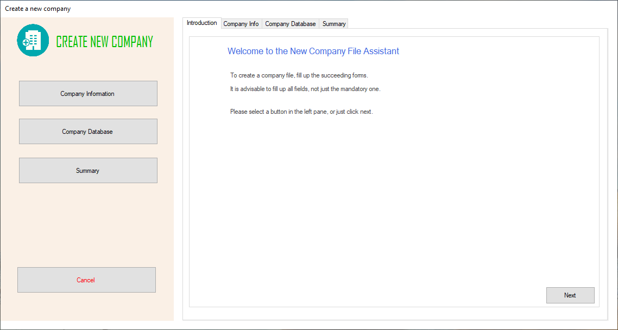

1. The Company Information tab will be displayed. Enter the company’s information then click **Next**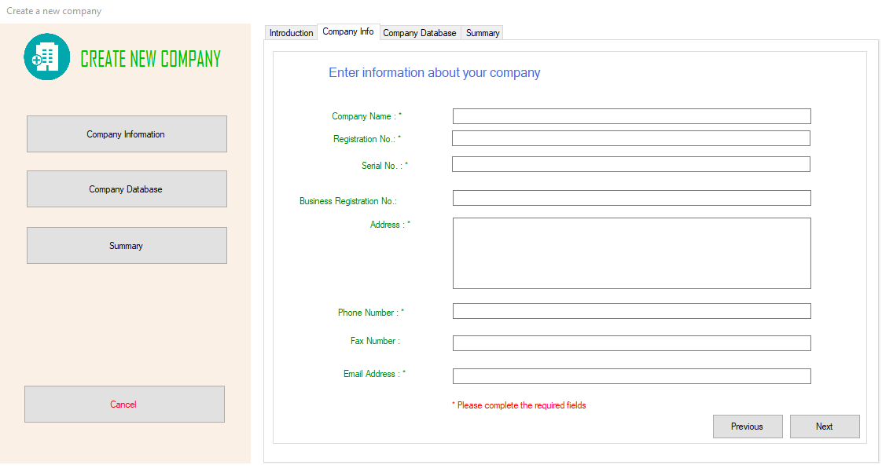
2. The Company Database tab will be displayed. Fill this section about your server and database information then click **Next.** 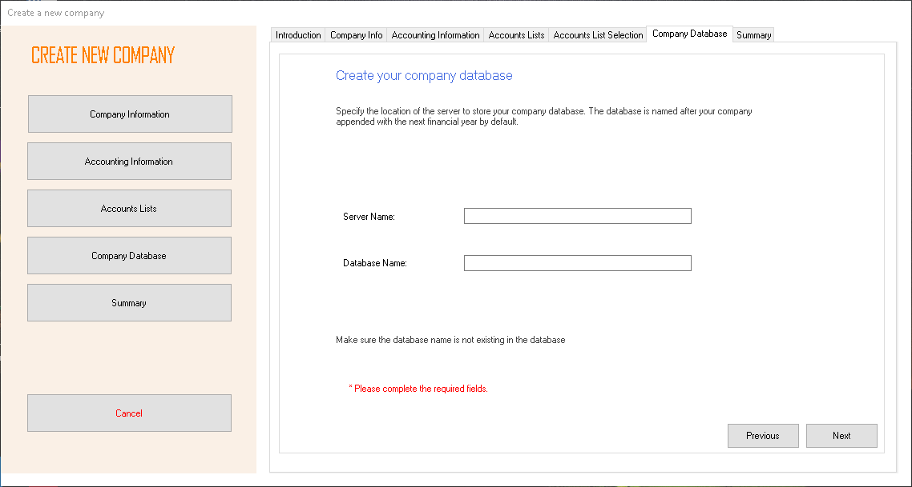
3. Summary tab will be displayed. Review the company information you entered then click **Proceed**. 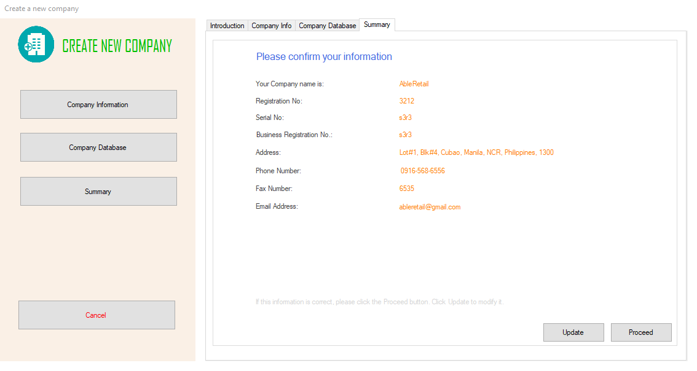

## Login

1. Start Able Accounting System
2. The Company Files will be displayed. Select a company then click **Login** or double click the desired company to login.

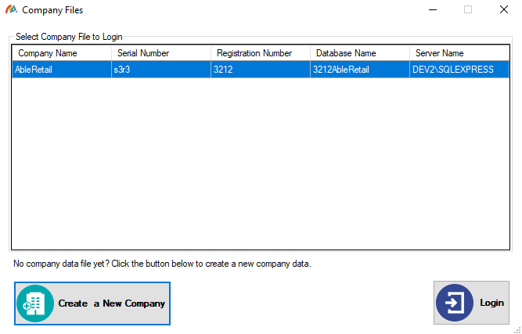

1. Login form will be displayed. Enter the Username and Password then click **Login**.

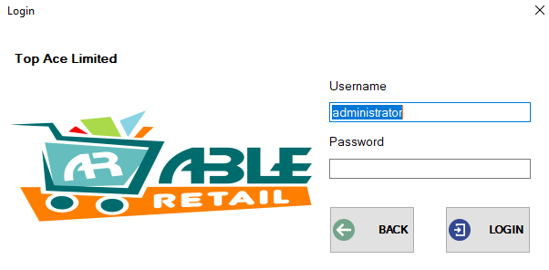

1. The Main page will be displayed.

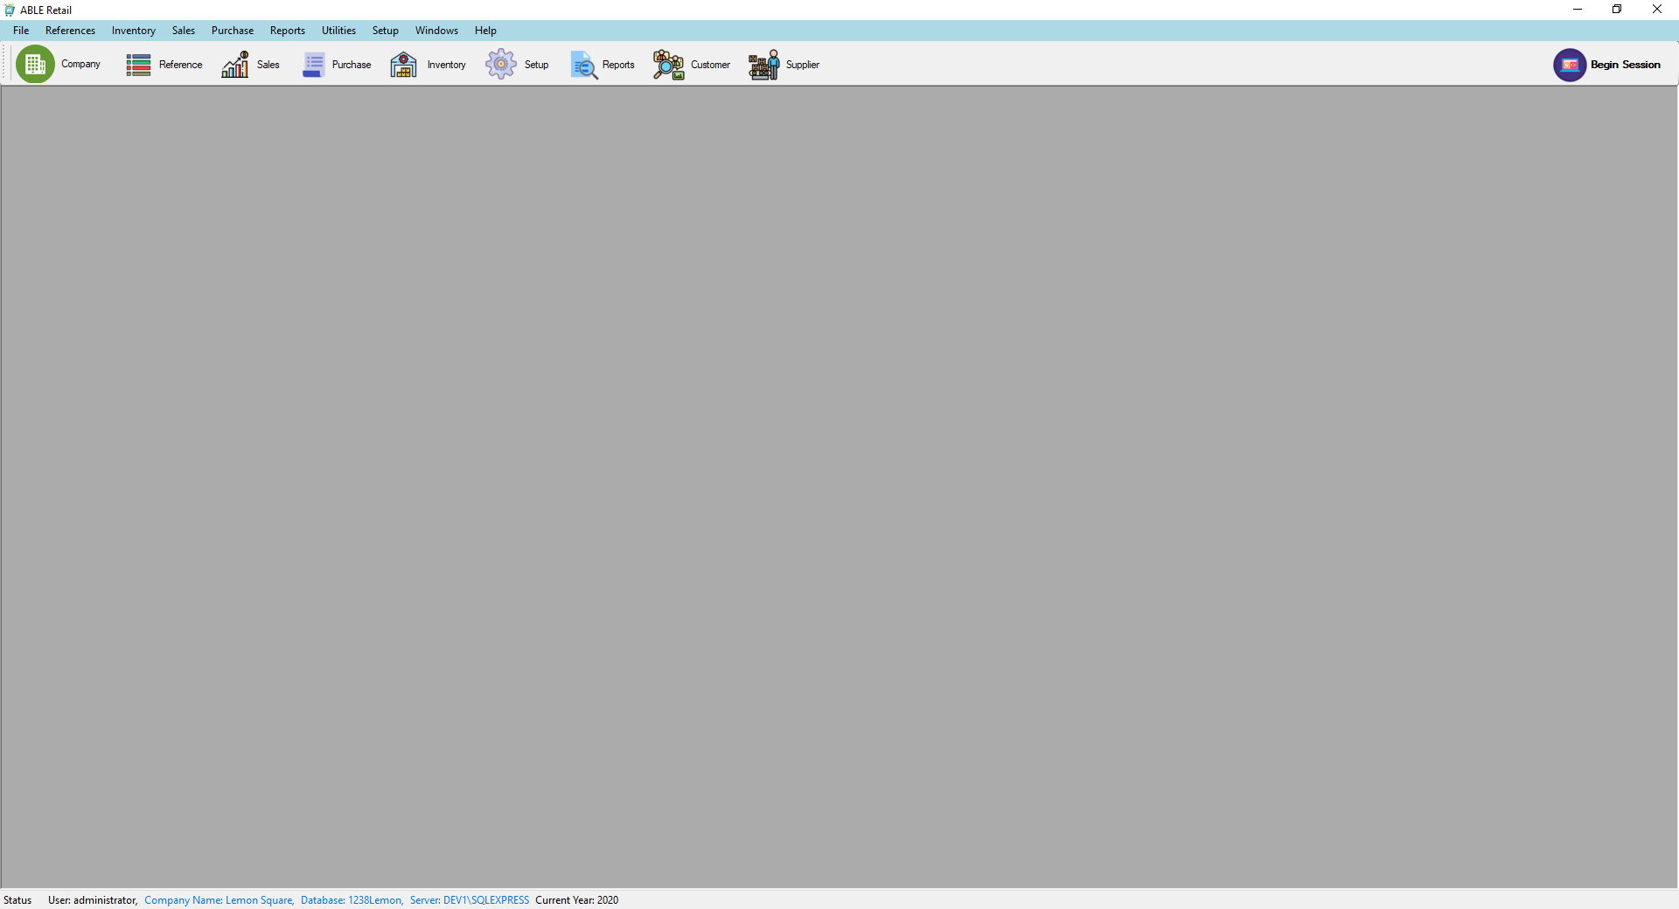

## Setting up using existing Database

First setup the SQL Server to be enabled to access using IP address.

1. Go to SQL Server Configuration Manager of your computer by typing **SQL Server Configuration Manager** on your Startor **Windows key + R** to Open the run window then type **compmgmt.msc** then click **OK** or Right click the Windows Start then click **Computer Management** then go to **Services and Applications**.
2. In SQL Server Configuration Manager. Open SQL Server Network Configuration > Protocol for SQLEXPRESS.
3. Double click the **TCP/IP** Protocol.
4. Select **Yes** in the **Enabled** field.
5. switch to the **IP Addresses** tab.
6. Find the **IPAll** section.
7. Clear the TCP Dynamic Ports field and fill the TCP Port with the **Default Port.** To know the Default Port see 1.3.1 Default Port.

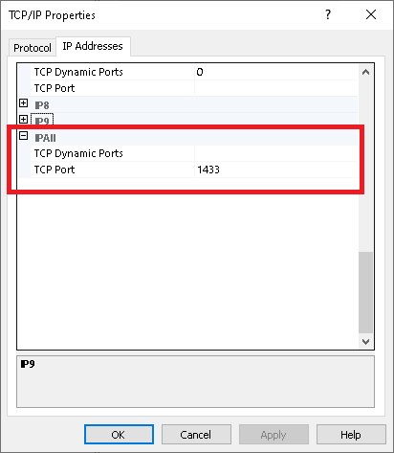

1. Restart SQL Server Service.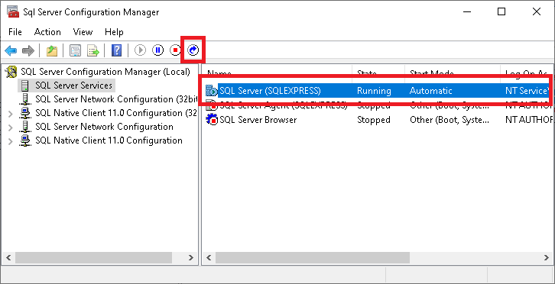
2. Open CoProEditor of the connecting pc then click **Browse.** Select the config.json file where your Able Accounting System is installed.

Note: connecting pc is the computer that wants to connect to the database.

1. Enter your company details. As Server Name use the IP address of the computer where the server is installed plus default port use comma as separator. Example, 192.128.243.21,1433 then click **Save**.

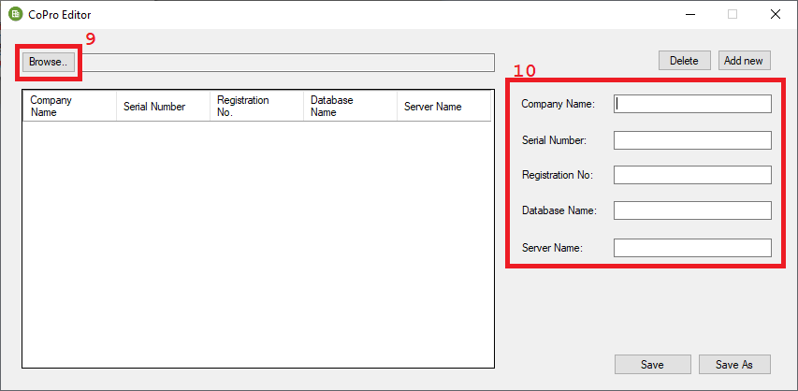

Note: Make sure that the server and the connecting pc is in the same network.

### Default port

1. In the SQL Server Configuration Manager. Go to SQL Native Client Configuration > Client Protocols Double click TCP/IP. 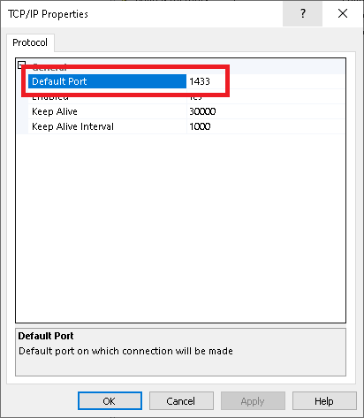

# Setup Guide

Before you can start recording transactions, you need to setup necessary records and settings on the on the system. The Setup Guide function provides you the list of system-related and data-related configurations that you must complete prior to going live. Click on the buttons to open the form that allows you to configure the settings.

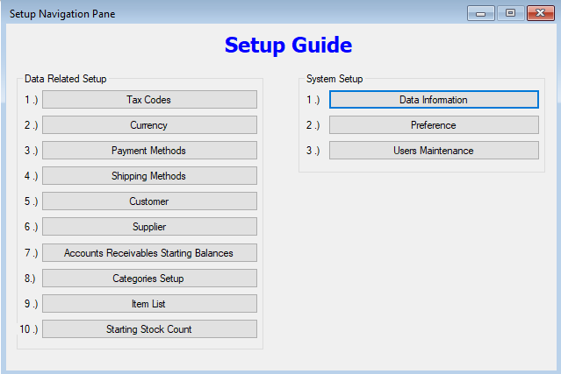

## Data Related Setup List

### **Tax Codes**

Tax codes to be used by the system must be completely setup to avoid data errors. There are already three default tax codes upon creating a company file. However, you must complete the setup to assign the tax rate and GL codes to be used by the Tax Code. Tax Codes can be accessed from the setup guide or from References->Tax Codes.

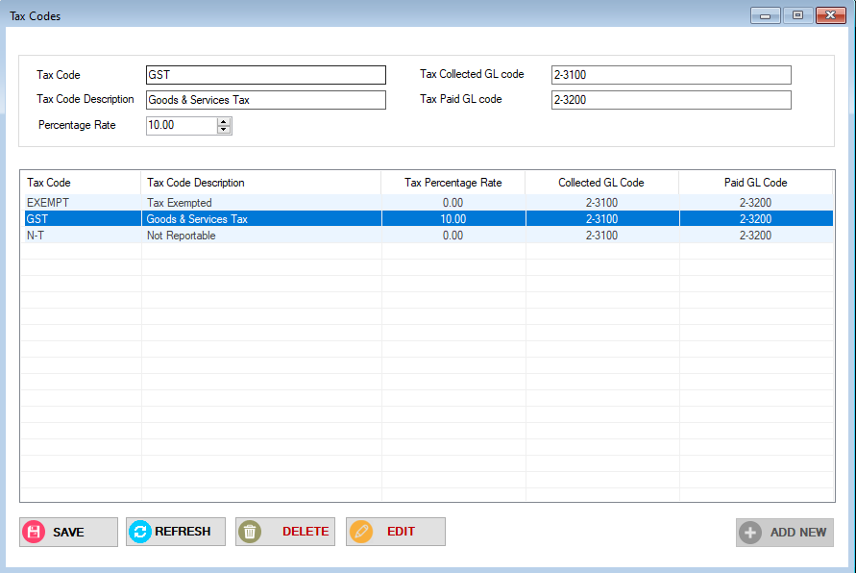

**Add New Tax Code**

1. From the Tax Code form, click on ADD NEW button.
2. Enter the Tax Code, Description, Percentage Rate, Tax Collected GL Code and Tax Paid GL Code on the field provided.
3. Click on Save.

**Edit Tax Code**

1. From the Tax Code form, select the tax code to be edited from the list.
2. Modify the tax code details and click Save.

**Delete Tax Code**

1. From the Tax Code form, select the tax code to be deleted from the list.
2. Click on DELETE.

### **Currency**

The PNG Kina default currency is already added upon creating a company file. At the moment, no further setup is required on the currency.

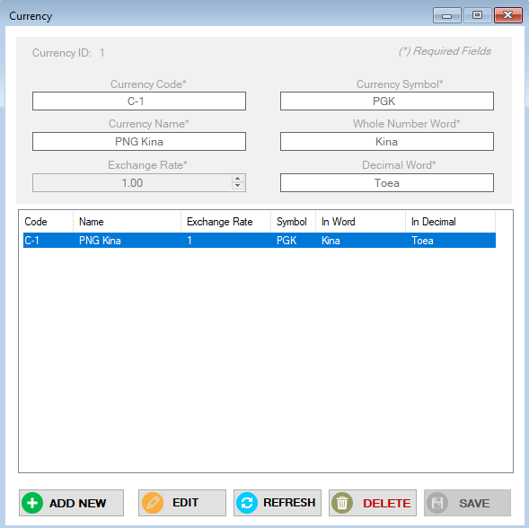

### Payment Methods

The payment methods to be used on sales and A/R payments are maintained under References->Payment Methods. By clicking the Payment Method button under setup guide, it will also open the Payment Methods dialog.

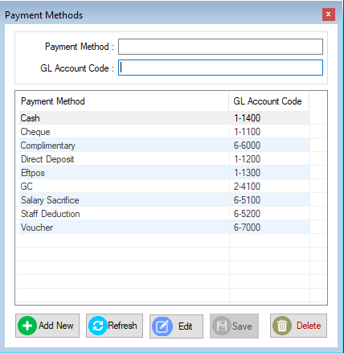

Each payment method must have a corresponding GL Code to use and must be specified when adding a new one.

**Add New Payment Method**

1. From the Payment Method dialog, click on Add New button.
2. Enter the payment method and GL Account Code to use on the field provided.
3. Click Save.

**Edit Payment Method**

1. From the Payment Method dialog, click on Edit button.
2. Select the payment method to modify then do necessary changer required.
3. Click Save.

**Delete Payment Method**

1. From the Payment Method dialog, select the payment method to delete.
2. Click Delete.

### **Shipping Methods**

The shipping methods to be used on sales transactions are maintained in Shipping Methods dialog. You can access the dialog from References->Shipping Methods or use the Shipping Methods button from the Setup Guide dialog.

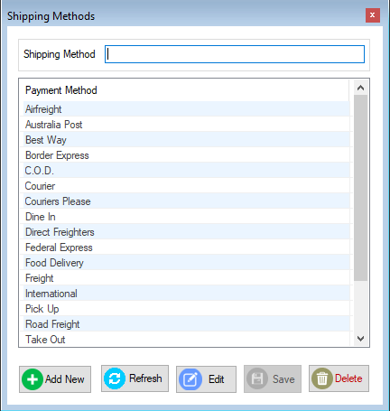

**Add New Shipping Method**

1. From the Shipping Method dialog, click on Add New button.
2. Enter the Shipping method on the field provided.
3. Click Save.

**Edit Shipping Method**

1. From the Shipping Method dialog, click on Edit button.
2. Select the Shipping method to modify then do necessary changes required.
3. Click Save.

**Delete Shipping Method**

1. From the Shipping Method dialog, select the payment method to delete.
2. Click Delete.

### **Customers**

Customers dialog can be access from different options in Able Retail. You can find the Customers button on the main window of Able Retail just below the main menus. It can also be accessed from References->Customers or from the Setup Guide dialog.

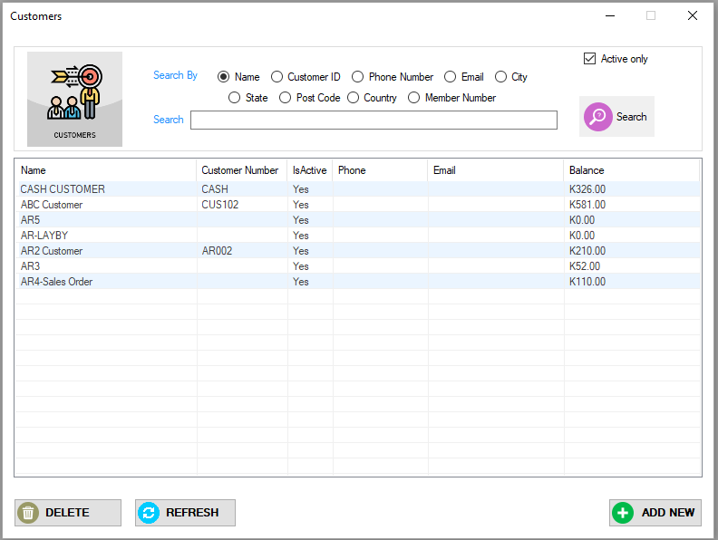

**Add New Customer**

1. From the Customers dialog, click on Add New button to open the Customer Maintenance dialog.
2. Enter customer details in the Customer Maintenance dialog. (Refer to Customer Maintenance)
3. Click Save.

**Edit Customer**

1. From the Customers dialog, search for the customer to edit.
2. Select the customer from the search list then double click the customer to open the Customer Maintenance dialog.
3. Do necessary changes required.
4. Click Save.

**Delete Customer**

1. From the customer dialog, search and select the customer to delete.
2. Click Delete.

#### Customer Maintenance

**Customer Info Tab**

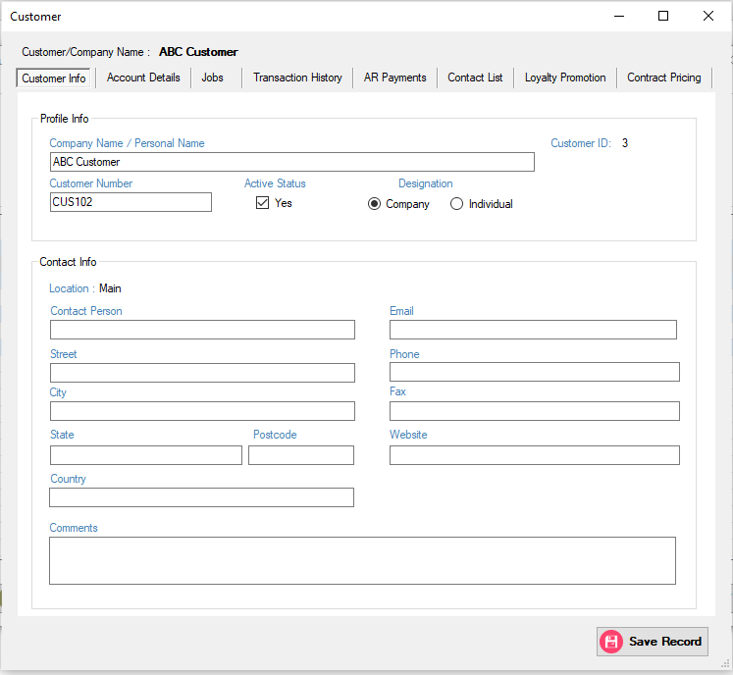

**Account Details Tab**

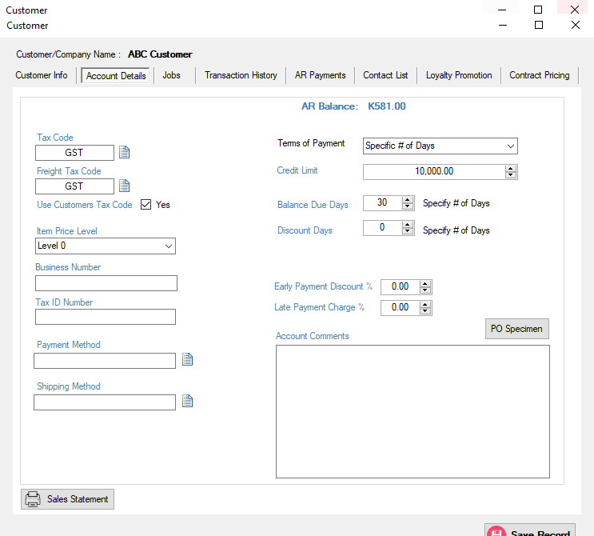

|  |  |
| --- | --- |
| Fields | Description |
| Tax Code | Tax Code of the Customer |
| Freight Tax Code | Tax Code for Freight for the Customer |
| Item Price Level | Price Level to be used by the customer |
| Business Number | IPA/Business Number of the Customer |
| Tax ID Number | TIN |
| Payment Method | Default Payment Method used by the customer |
| Shipping Method | Default shipping method used by the customer |
| Terms of Payment | Choose between 2 options:   1. Cash 2. Specific # Of days – assign this option if customer is on credit |
| Credit Limit | Credit limit of the customer |
| Balance Due Days | Number of days that the customer must pay the credit |
| Discount Days | If providing discount for early payments, enter the number of days when can the customer be discounted for early payments |
| Early Payment Discount % | Rate of discount when customer pays within the discount days |
| Late Payment Discount % | Rate of late payment fee |
| Account Comments | Enter any comments needed for the customer account |
| PO Specimen Button | Use this to upload image of PO specimen from the client. |
| Sales Statement Button | Use this to generate statement of the customer |

**Jobs Tab -** list the invoices that are linked to certain jobs by date range.

**Transactions Tab –** list all sales transactions by date range and sales type.

**AR Payments Tab –** list all payments made by the customer.

**Contact List Tab –** shows all contacts added to the customer account.

**Loyalty Promotion –** show the accumulated points and redeemed points by the loyalty member linked to the customer account.

**Contract Pricing –** provides the interface to add contracted price of the customer by inventory item.

### **Suppliers**

Suppliers dialog can be access from different options in Able Retail. You can find the Suppliers button on the main window of Able Retail just below the main menus. It can also be accessed from References-> Suppliers or from the Setup Guide dialog.



**Add New Supplier**

1. From the Suppliers dialog, click on Add New button to open the Supplier Maintenance dialog.
2. Enter supplier details in the Supplier Maintenance dialog. (Refer to Supplier Maintenance)
3. Click Save.

**Edit Supplier**

1. From the Suppliers dialog, search for the supplier to edit.
2. Select the supplier from the search list then double click the customer to open the Supplier Maintenance dialog.
3. Do necessary changes required.
4. Click Save.

**Delete Supplier**

1. From the supplier dialog, search and select the supplier to delete.
2. Click Delete.

#### Supplier Maintenance

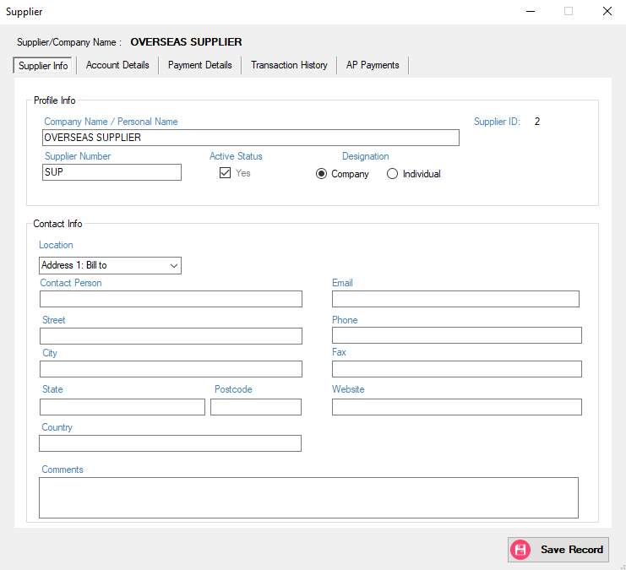

### **Accounts Receivables Starting Balances**

Enter your customers current balances prior to your live date in the Accounts Receivable Starting Balances. When opening the menu, the list of A/R customers are shown on the list. Accounts Receivable Customers are customers that have a Terms of Payment set to **Specific Number of Days**.

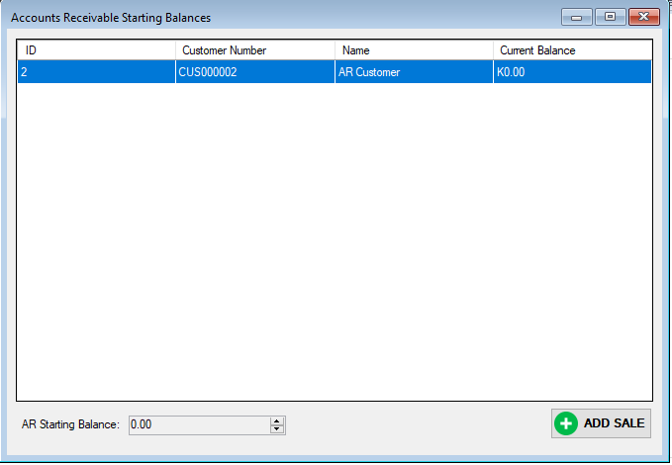

Select the customer on the list and click **ADD SALE** button to open the AR Balance Entry form. Enter the details of the customer balance and click Record.

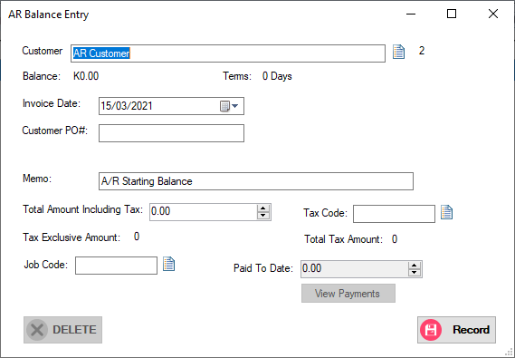

### **Categories Setup**

See Inventory

### **Item List**

See Inventory

## System Setup List

### Data Information

This contains the company information that you had setup when you created the company profile. You may update the details of the company on this form.

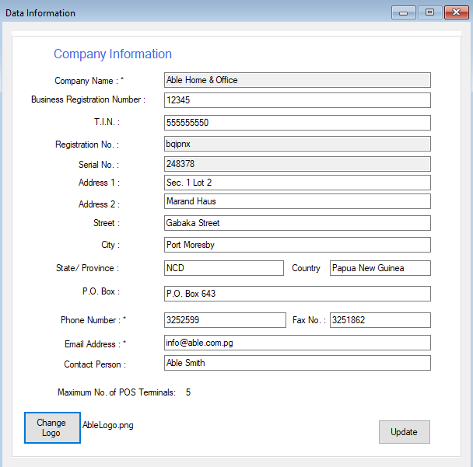

If you would like to assign a logo to appear on your invoices, you need to save the image file of the company logo to the installation folder of Able Retail (Example: C:\Able Retail) then assign the logo thru the Change Logo button. When the Change Logo button is clicked, it browse the filename of the logo image you saved in the installation folder of Able Retail.

### Preferences

### Click on the Preference button to open the **Preferences** form. Alternatively, you can also open the Preferences form from Setup->Preferences.

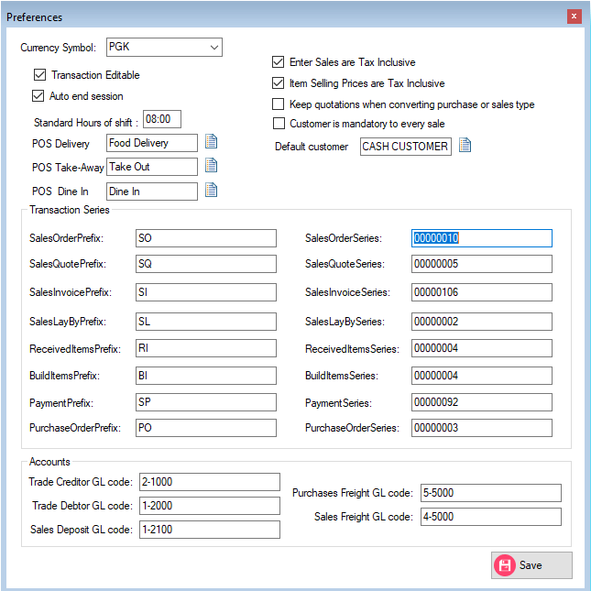

|  |  |
| --- | --- |
| Settings | Description |
| Currency | Choose the currency from the drop-down list. *NOTE: Only one currency is supported at this time. |
| Transaction Editable | If enabled, the transactions can be edited. *NOTE: If payments had been applied to a sales transaction, editing is not anymore allowed. |
| Auto End Session | If enabled, POS session will end automatically based on the standard hours of each cashier shift.  If not enabled, a user manually end the POS session.  *NOTE: It is recommended to have one session per cashier shift. |
| Enter Sales are Tax Inclusive | If enabled, prices that show in Sales functions (Enter sales, Quick Sale, Restaurant POS) are tax inclusive. |
| Item Selling Prices are Tax Inclusive | If enabled, you must setup all prices of items as tax inclusive. This means, every time you assign a price to a certain item, it is always tax inclusive if this option is enabled. |
| Keep quotations when converting purchase or sale | If enabled, quotations are retained in the system after converting it to a different sale type.  If not enabled, quotes are deleted once converted to other sale type. |
| Customer is Mandatory to every sale | If enabled, a user needs to assign a user for every sale.  If not enabled, you need to specify a default customer name that the system will use for every sale on the Default Customer field. |
| POS Delivery | Assign the shipping method to be used when using Delivery on Restaurant POS interface |
| POS Take-Away | Assign the shipping method to be used when using Take-Away on Restaurant POS interface |
| POS Dine In | Assign the shipping method to be used when using Dine In on Restaurant POS interface |
| Transaction Series & Prefixes | For each type of transaction in the system, you can nominate a prefix and a series number that Able Retail will use. |
| Accounts | Able Retail will create journal entries that you can export later or use on your Accounting system. You have to specify GL Account codes you are using for the following:  Trade Creditor GL Account  Trade Debtor GL Account  Sales Deposit GL Account  Purchase Freight GL Account  Sales Freight GL Account |

### User Maintenance

Allows the administrator manage users and assign user rights

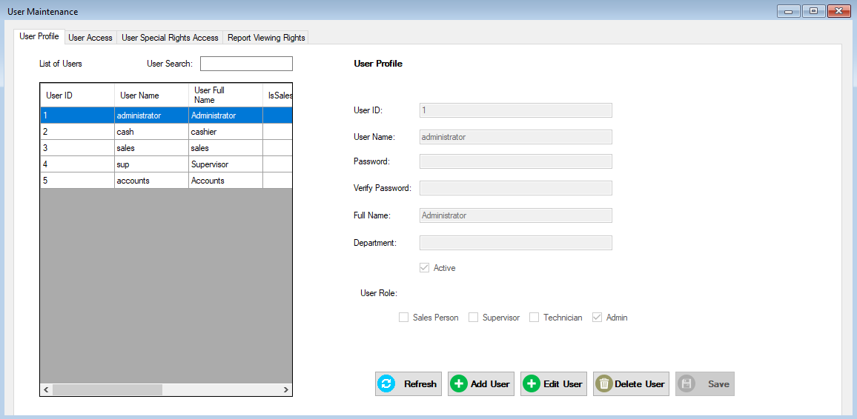

#### Creating new users.

1. Go to **Setup** and click **User Maintenance**. 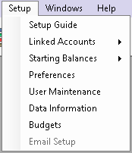
2. The **User Maintenance** form will be displayed.Click **Add User**.
3. Enter the new user, User Name, Password, Full Name and Department, Check the active box and click **Save**.

#### User Access

The User Access tab allows you to grant access to each form or menu on the system.

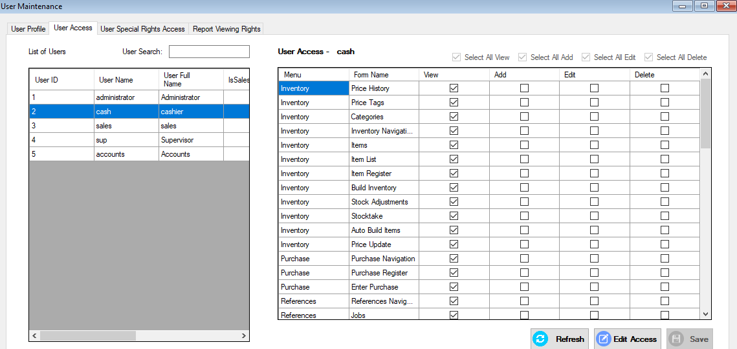

1. Go to **Setup** and click **User Maintenance**.
2. The **User Maintenance** form will be displayed. Go to **User Access** tab.
3. Change the user access by checking and unhecking the box for either View, Add, Edit, Delete access for each form in the system.

#### *User Special Rights*

The special rights are used to allow or disallow access to certain fields on some modules in Inventory, Purchases, Sales and Customers.

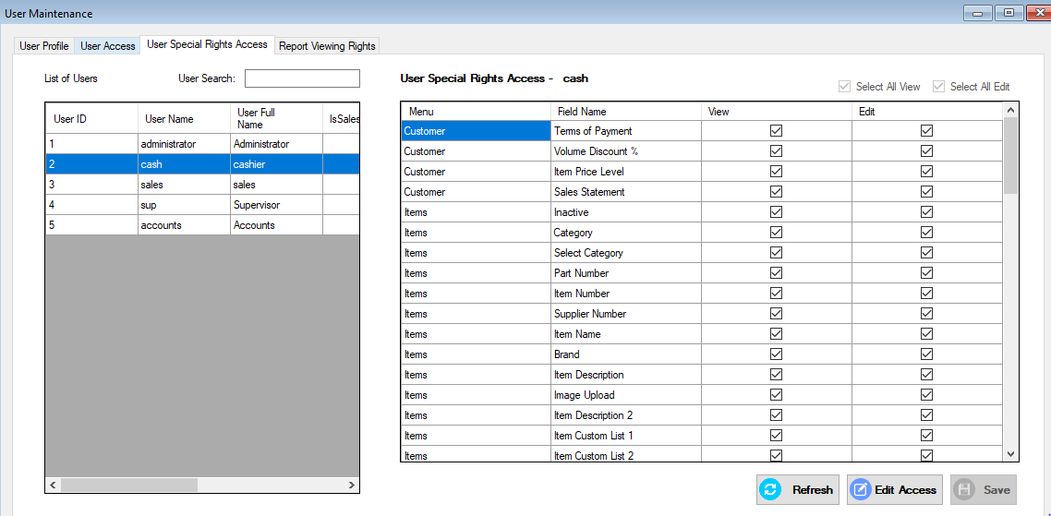

1. Go to the **User Maintenance->User Special Rights Access**.
2. Click Edit Access then Select the user you desire to change the special access in the users list. Check the box to the corresponding rights for the user.
3. Click **Save**.

#### Report Viewing Rights

The report viewing rights are used to allow or disallow access to specific reports.

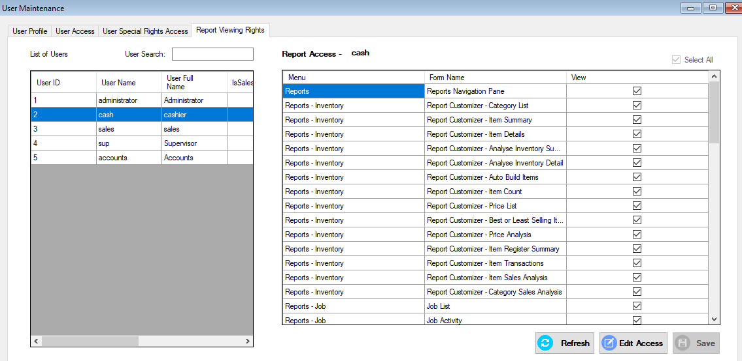

1. Go to the **User Maintenance->Report Viewing Rights**.
2. Click Edit Access then Select the user you desire to change the reports viewing rights in the users list. Check the box to the corresponding rights for the user.
3. Click **Save**.

#### Changing Password

1. Go to **Setup** and click **User Maintenance**.
2. The **User Maintenance** form will be displayed. Select the user that the password needs to be changed.
3. Changed the password and verify the new password.
4. Click **Save**.

## Terminal Setup

The number of POS terminals you have determined the instances of POS modules that you can use simultaneously across all users using the same database. You can assign the names of your POS terminals under Utilities->Terminal Setup.

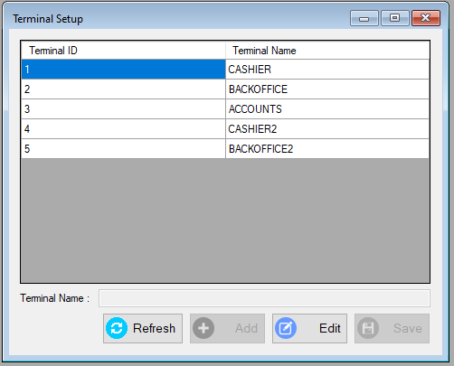

To add a new terminal, click on the ADD button then type the terminal name you would like to assign. Click Save when done.

To edit the name of an existing terminal, simply select the terminal to edit from the list then click on EDIT button. Do necessary changes on the terminal name on the field provided then click SAVE button.

Please note that you can add up to the maximum POS terminal licence you are entitled to.

# Inventory

Enable you to keep track of the quantity and values of your item.

## Category

Items can be divided into categories. Category has main category and sub category. You can set the GL codes to be used for Income, Cost of Sale and Inventory on the sub category.

Creating New Category

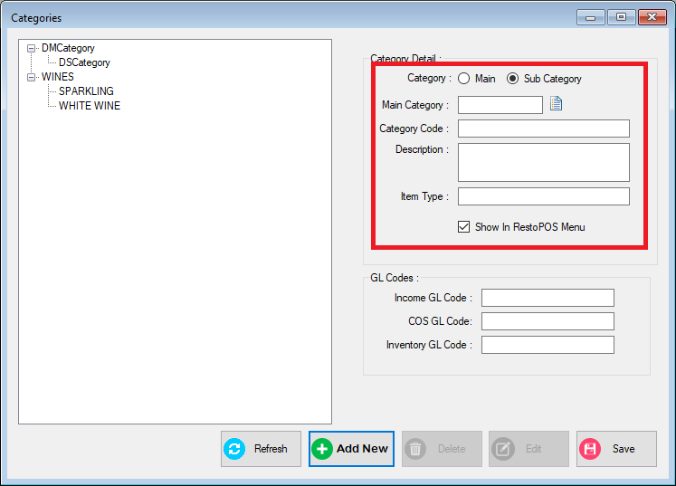

1. Click **Add New** button. Select if the category is Main or a Sub Category. Then input the Category Code Description and Item Type.
2. Sub Category need a main category. Click the look up(  ) button and select its main category.
3. Click **Save** to add the new Category.

Note: Only the Sub Category has a GL Code for the gl code of the for the items that will belong to the category.

Editing Existing Category

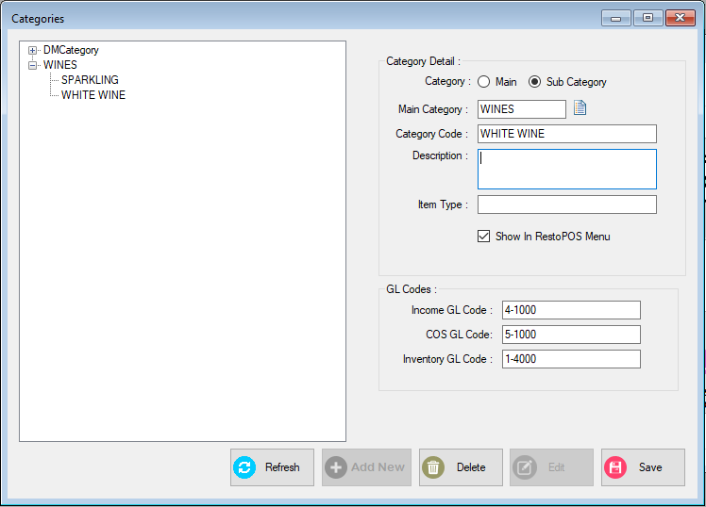

1. Double click the category that will be edited then the click **Edit** button.
2. Edit the changes. Then click **Save.**

Deleting a Category

1. Select the Category to be deleted then click Delete button. Click Refresh to see the changes.

## Creating Items

Before you can track your inventory, you need to create a record for each item of your inventory.

**To create an item**

1. Click **Inventory** and click **Items** to open **Item List** form**.**

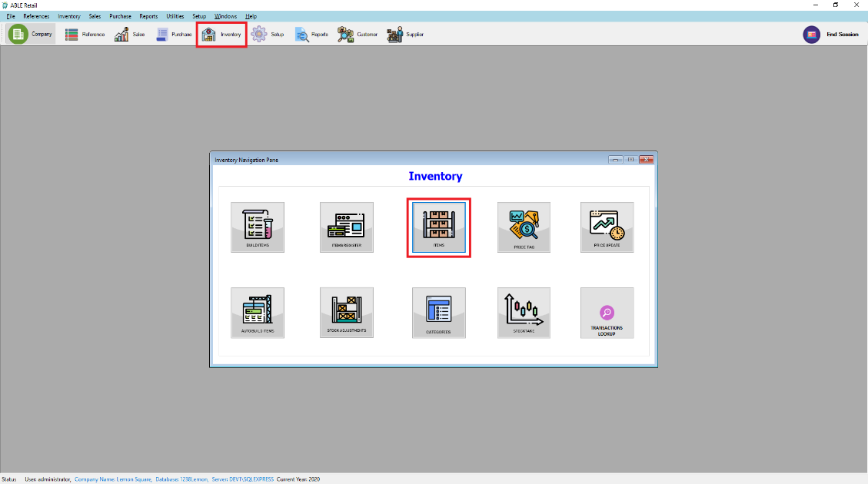

1. Click **Add New.**
2. The Item form will be displayed. Enter the item information.

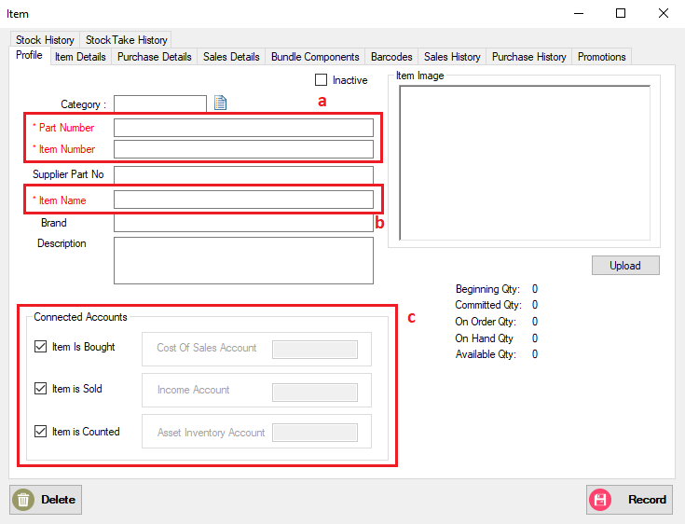

* 1. Enter a unique identifier for the item.
  2. Name of the item.
  3. [Required] Check the box to select which account to associate the item to keep track when the item is bought, sold and in the asset account.

1. Go to **Item Details** tab to enter the item description.
2. Go to **Purchase** **Details** tab to enter the detail when buying the item.

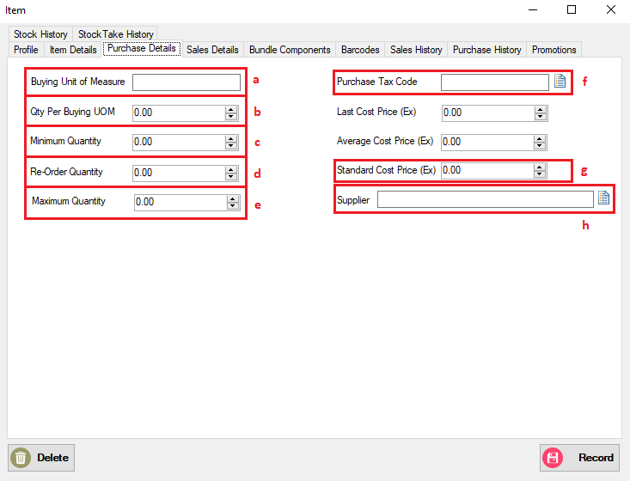

* 1. Type the unit of measure in which you purchase the item.
  2. [Optional] The Qty Per Buying Unit Of Measure
  3. [Optional]The minimum quantity of item you want to keep in your inventory. When the item drop below this level, a reorder reminder will appear in **To Do List.**
  4. A Reorder quantity of the item.
  5. [Optional]The maximum quantity of item you want to keep in your inventory.
  6. The Standard cost of the item.
  7. The supplier you order the item.

1. Go to **Selling** **Details** tab to enter the detail when selling the item.
   1. Unit of measure when reselling the item.
   2. Set the tax code to use when reselling the item. Can be change in the invoice.
   3. Select Sales Date Range for this item.
   4. Price of the item when reselling.
   5. Enter the different pricing level for different customers.

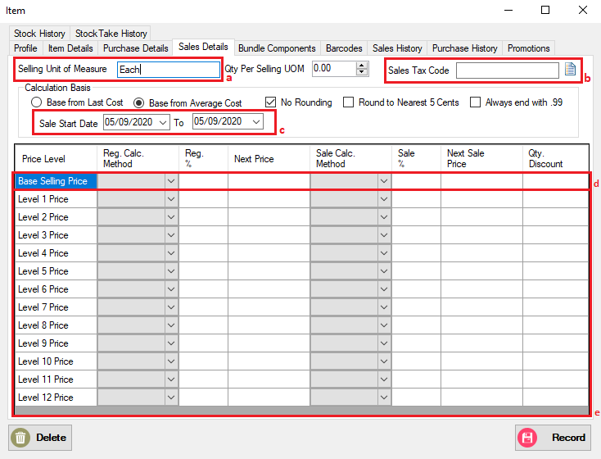

1. Click **Record.**

## Building Items

Building items is the process of combining two or more items to make up another item.

### To build item manually

1. Go to **Inventory Navigation Pane** and click **Build Items.**
2. The **Build Item** form will be displayed. Type or Select the part numbers you want to make and the component items you want to transfer.
3. Type the transfer quantity.
   1. Type the positive number for the finished item (This number is added to your on-hand inventory).
   2. Type the negative number for the component items (This number is subtracted to your on-hand inventory).

Note: Out of Balance field must be zero before you can record the transaction.

1. Click **Record** to save inventory transfer.

### To define an auto-build item

Auto-build items are items that you frequently build. Before you can build the finished item, you need to define the items that you need.

1. Go to **Inventory Navigation Pane** and click **Items**. The **Item List** form will be displayed.
2. Double click the item and go to **Auto-Build Components** tab.
3. Check the This is an Auto-Build Item.
4. Click **Add Part**. An Item List will be displayed select the item you want to add in the auto build item.

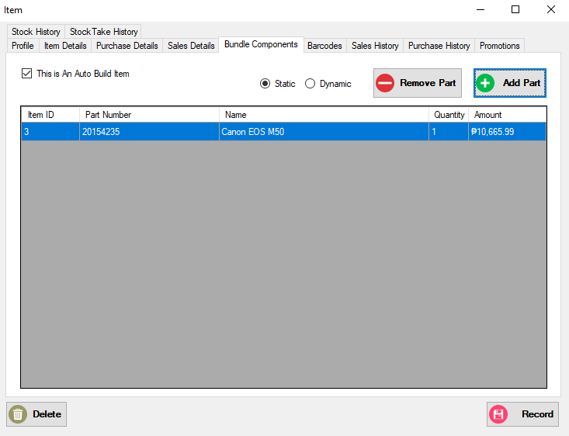

1. Change the quantity of the item then click **Record**.

### To auto-build an item

1. Go to **Inventory Navigation Pane** and click **Auto Build Item**. The **Auto Build Item** form will be displayed.

## Price Update

The Price Update dialog allows you to modify prices of your items in bulk as opposed of doing it per item in the Items Maintenance. You can open the Price Update dialog from Inventory->Price Update. Alternatively, you can also open the dialog using the Price Update button found in the Inventory Navigation Pane.

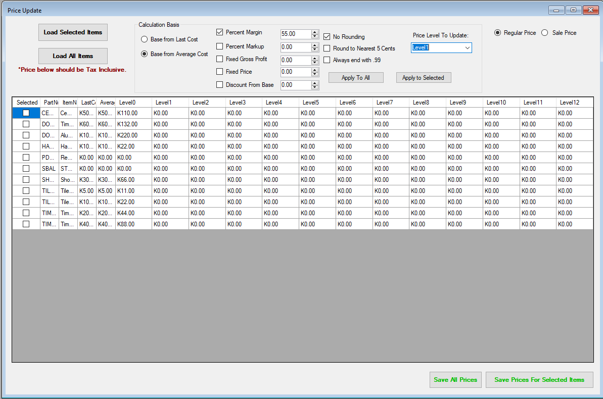

To update item prices, click on Load All Items or Load Selected Items. If you opt to load selected items, the item lookup dialog shows where you can search the items and select it.

Once all items needed are included on the grid, choose your calculation basis whether base from Last Cost of Base from Average Cost. Select your calculation method and specify the percentage or fixed amount beside it.

There is also an option to round or format the calculated price. You may round it to the nearest 5 cents or you may want to end it with .99.

Select the price type, whether Regular Price or Sale Price then select the price level to update from the drop-down. If you are changing the Sale prices, you must specify the sale start and sale end date.

To calculate the new price based on the criteria indicated, click on Apply to All button or Apply to Selected button.

To save the new calculated price to the items, click on Save All Prices or Save Prices for Selected Items.

## Price Tag

Able Retail allows you to print price tags from the system.

## Stock Adjustments

## Stocktake

# Sales

This chapter show how to record sales transaction to your customers.

## Creating a customer profile

1. Go to **Reference** and click **Customer** or click **Customer** in the tool strip.

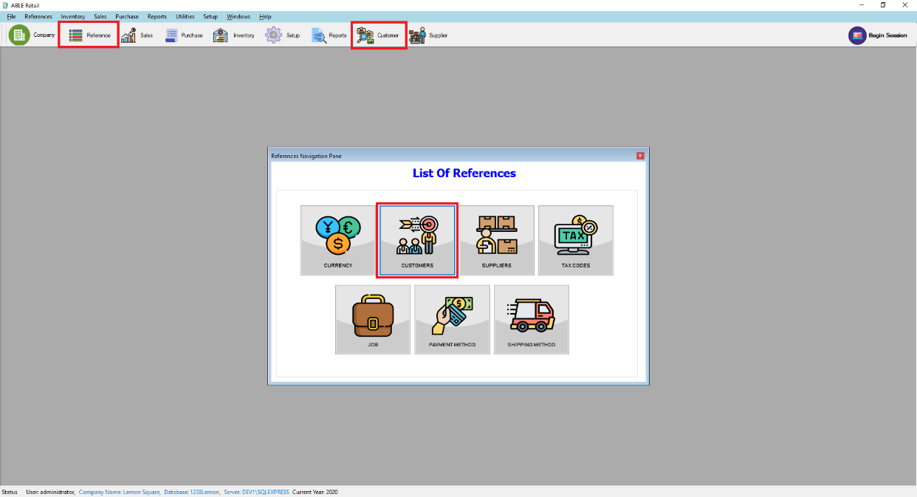

1. The customer list will be displayed. Click **ADD NEW**. 
2. The add customer form will be displayed. Enter your customer information. If the company has more contact information. Select Address 2 from the location list and enter the additional contact information. A company can enter five contact information. 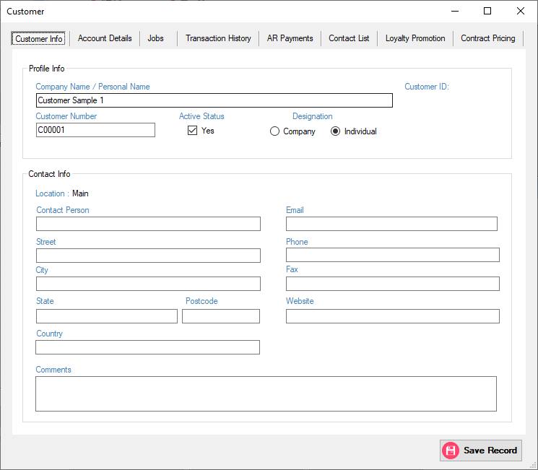
3. Go to Account Details Tab to enter your customer payment method your customer will use to pay you. Fill the necessary details then click **Save Record**. 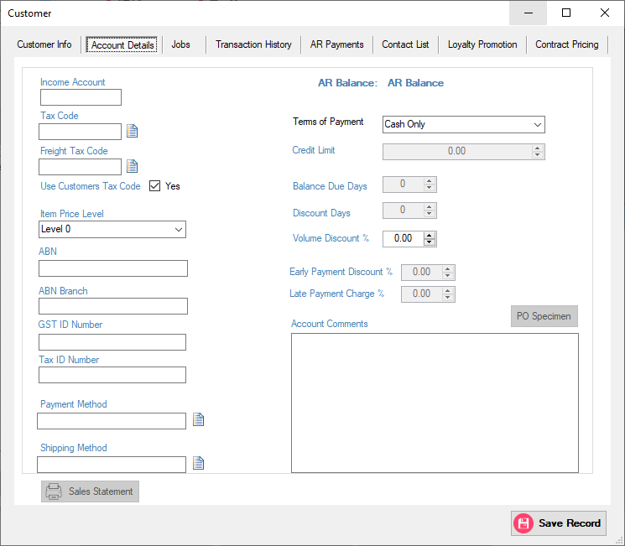

## Entering Sales

1. Start a Session. Click **Begin Session** then enter the opening fund in the cash drawer and **Terminal** then click **Save.**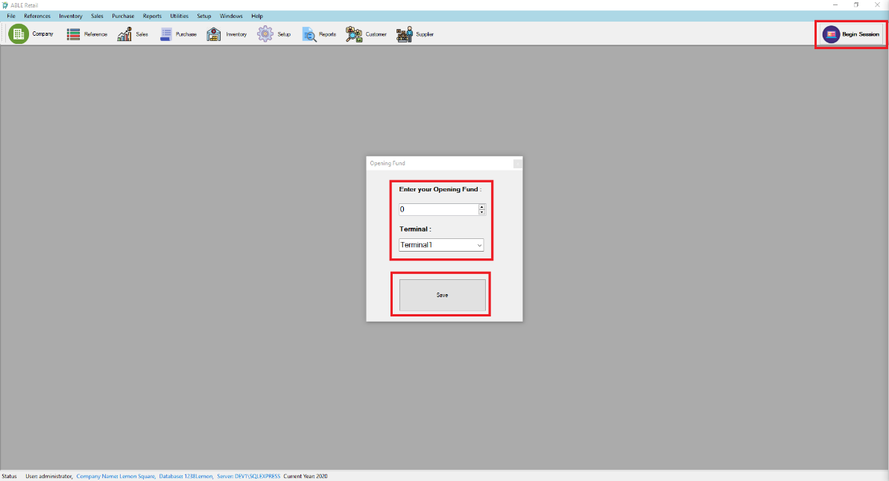
2. Click **Sales** in the tool strip to show the Sales Navigation Pane then click **Enter Sales**.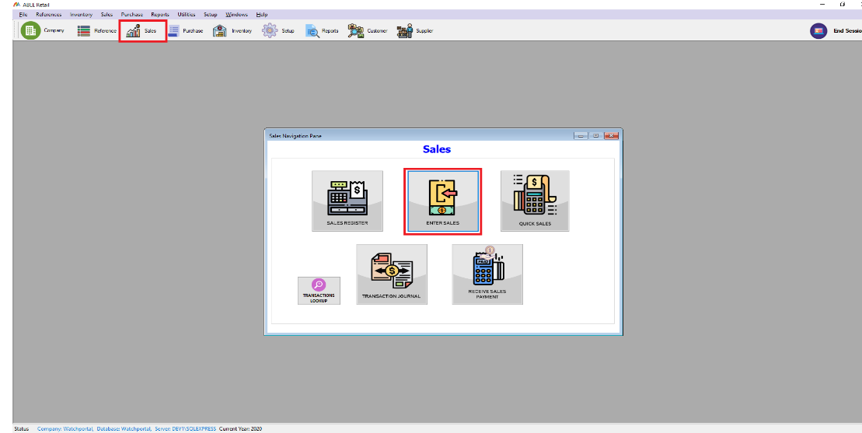
3. The Enter Sales form will be displayed.
4. Enter Sales Details. 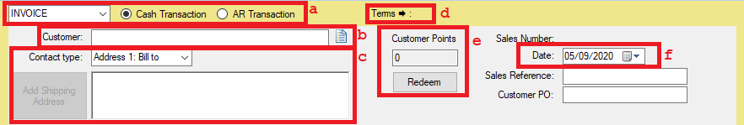
5. Select the type of sales you want to record.
6. Click the icon ( ) in customer field, The customer profile lookup will appear and choose a customer.
7. [Optional] Default Ship to address is Address 1.
8. [Optional] Click to change term for this sale. Default value will be the value entered in customer account details.
9. [Optional] Use Points to redeem items.
10. [Optional] Transaction Date change when transaction occurred.
11. Entering transaction lines of the sale. The illustration below shows the field for **Item Layout.**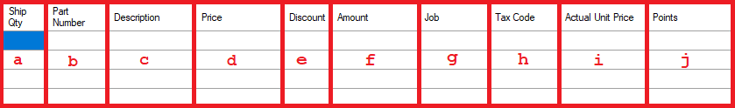
    1. Quantity of item to sold.
    2. Type or Double click to open Item lookup to select the item sold.
    3. Default is the description of the item. Can be change if you want.
    4. Default price is Base Selling Price. Can be change if desired.
    5. Percent of discount if desired to put a discount.
    6. Amount is Auto compute depending on price, Ship Qty., and discount.
    7. [Optional] Double click to display the Job Lookup to allocate the specific job.
    8. Select the tax code of the transaction line. Default is the tax code of the item.
    9. Actual Price of the item.
    10. Promo Points(6.Promotions).
12. Additional information of the sales. 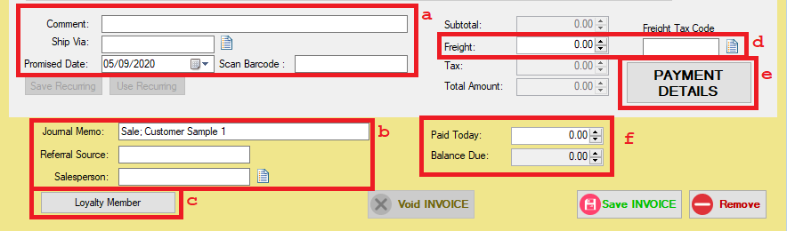
13. [Optional] Comment, Promised Date ,Ship Via click the icon  to display shipping method lookup.option to scan barcode of the item.
14. Memo is automaticaly generated. Can be change if desired. Referral source is optional.

[Optional] Sales person assigned in the sale, click the icon  to open the Sales Person look up.

1. Loyalty Member[Optional] Enter the Loyalty Member Number of customer.
2. [Optional] Freight amount and Freight Tax Code of the sale.
3. Tender Detail of the sale, if paid using bank or credit card, etc. click the **Payment Detail.** Default Payment Method is the payment method set in the customer Account detail.
4. Display the amount paid and balance due.
5. Click **Record** to save the sales transaction or [Optional] Click **Save Recurring** if the transaction will be regularly recorded**.**

## Quick Sale

1. Start a Session. Click **Begin Session** then enter the opening fund in the cash drawer then click **Save.**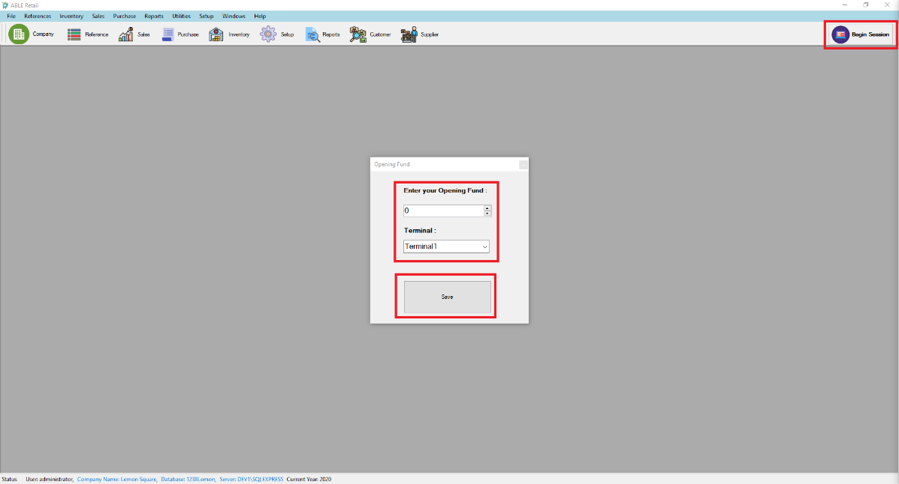
2. Click **Sales** in the tool strip to show the Sales Navigation Pane then click **Quick Sales**.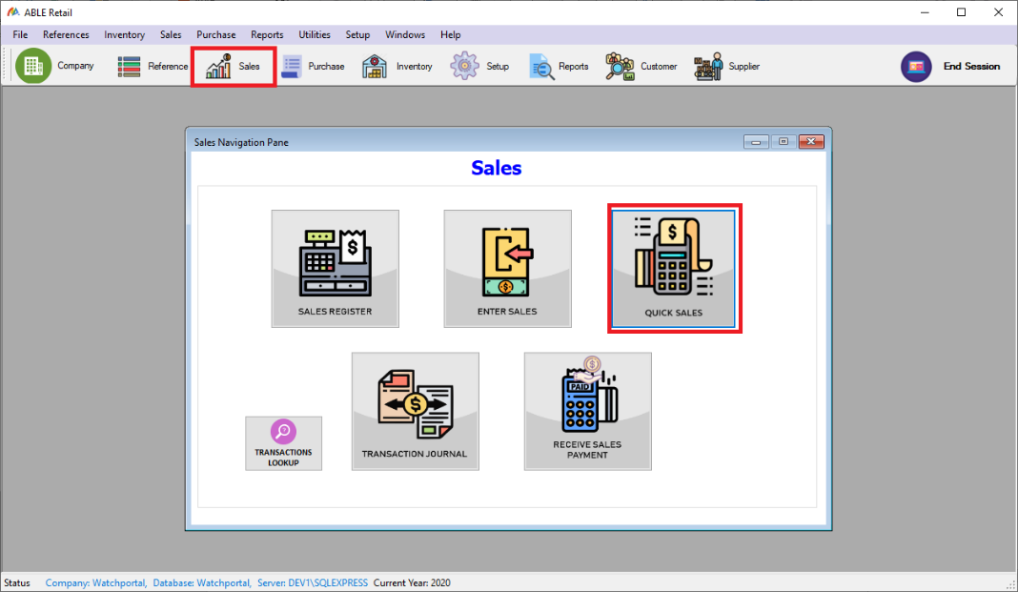
3. The Enter Sales form will be displayed.

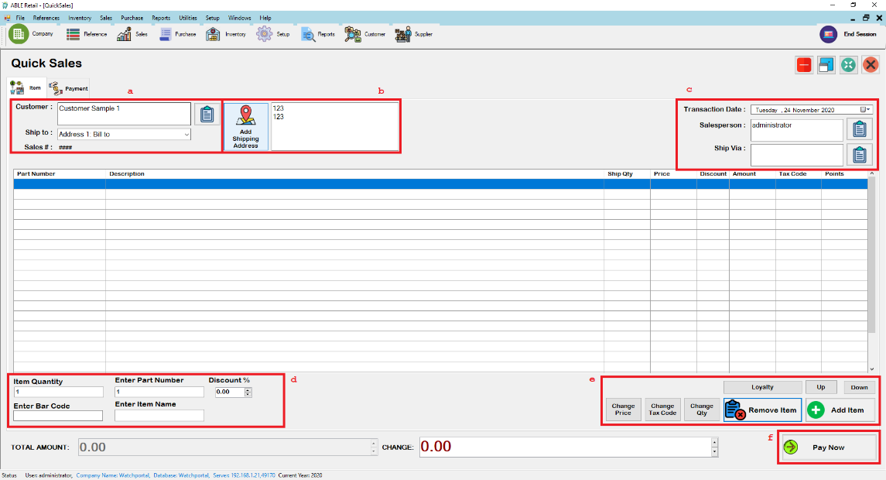

* 1. Click the icon ( ) in customer field, the customer profile.
  2. [Optional] Default Ship to address is Address 1.
  3. [Optional] Sales person assigned in the sale, click the icon to open the Sales Person look up.
  4. Type or use the barcode scanner to enter the item purchased by the customer.
  5. [Optional] Enter Loyalty Members number if customer is loyalty member, Change the price/Tax Code to use or quantity of the selected row, Remove and Add item from the table. Note* Sale Person need the supervisor to remove item in the table.
  6. **Pay Now.**

1. Tender Details of the sale.
   1. Select the payment method the user used to pay for the item.
   2. [Optional] Details of the transaction.
   3. Numpad to use to enter the amount.
2. Click **Record** to save the Transaction.

## Restaurant Point of Sale

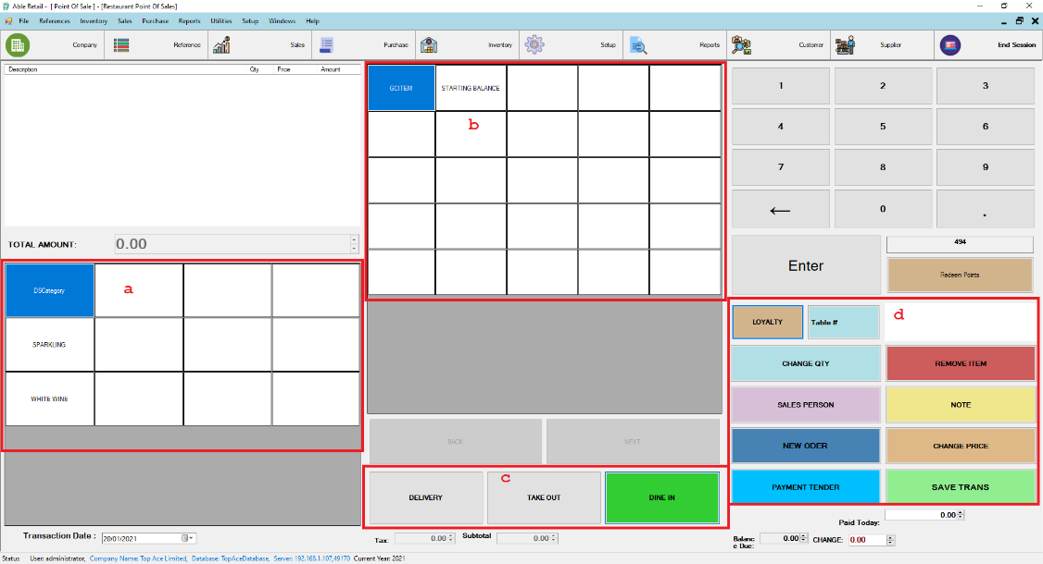

a. List of categories of the items.

b. List of items to be to be purchased.

c. Shipping method of the sale.

**Loyalty Member**[Optional] Enter the Loyalty Member Number of customer.

**Change Qty** to change the quantity of the selected index.

**Sales Person** to change the sales person in charge of the sale.

**New Order** for new Order.

**Change Price** to change the priice of the selected index.

**Note** for delivery and other notes.

**Remove Item**[Optional] needs user rights to remove item in the sale.

**Save Trans** to save the transaction

**Payment Tender** to enter the breakdown of the payment.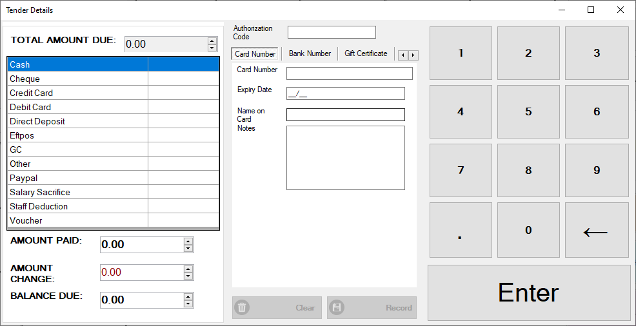

## Receiving Payment

1. Click **Sales** in the tool strip to show the Sales Navigation Pane then click **Receive Sales Payment**.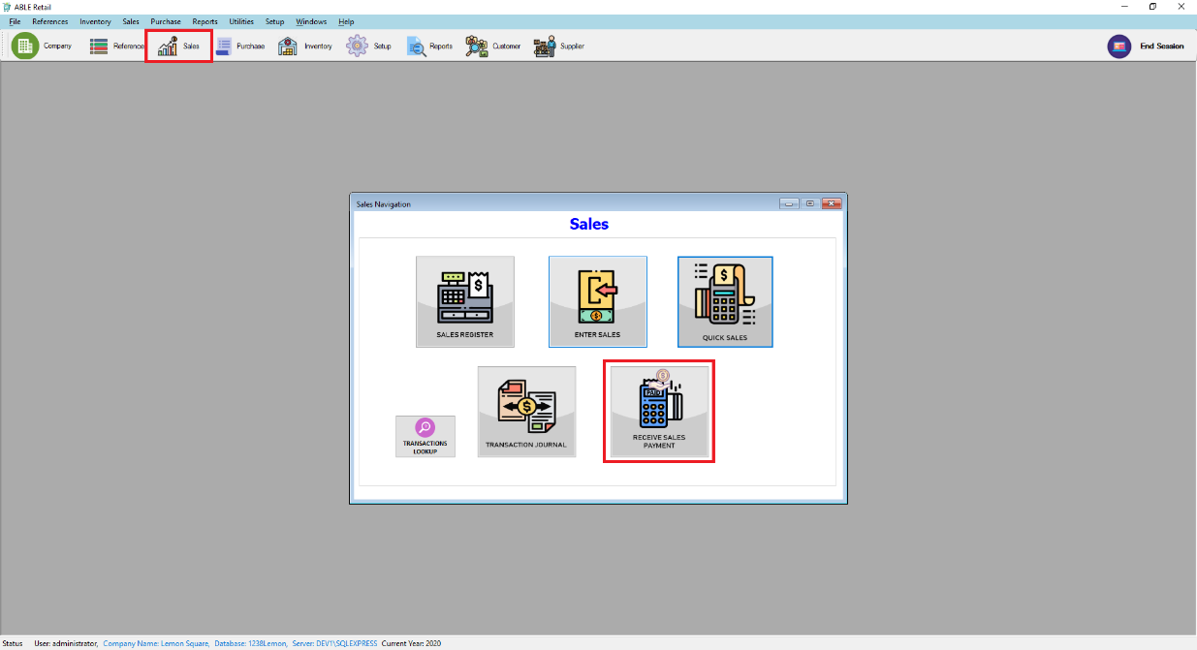
2. **Receive Sales Payment** form will be displayed.
3. Enter Payor details.

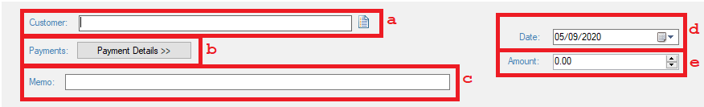

1. ****In the Profile field click to open the Profile Lookup then select the payor.
2. [Optional] Click the **Payment Detail** button to select the method of payment.
3. When selecting a profile automatic Memo will be generated. Can be changed if desired.
4. Change to when is the date of transaction occurred.
5. Amount sent by the receiver.
6. Allocate the amount to the appropriate sale.
7. [Optional] If you want to give a discount.
8. Amount you want to apply in each sale in the column.

Note: Out of Balance must be zero to save the transaction.

1. Click **Record**.

## Changing Status of a Sale

### To change a quote to an order or invoice

1. Go to Sales Navigation Pane and click **Sales Register**.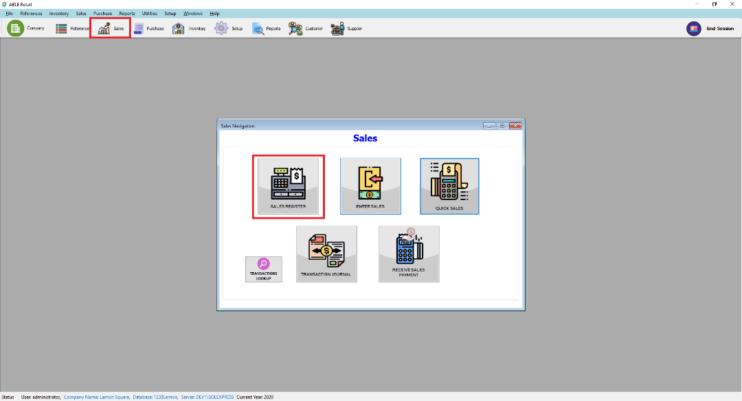
2. Sales Navigation Pane will be displayed. Click the **Quotes** Tab.
3. Change the dates to filter the date of the sale.
4. Select the desired sales record to change and click
   1. **Change to Order** if you want to change it to order.
   2. **Change to Invoice** if you want to change it to invoice.
5. Make necessary change if desired. For example, change the transaction date.
6. Click **Record.**

### To change an order to invoice

1. Go to Sales Navigation Pane and click **Sales Register**.
2. Sales Navigation Pane will be displayed. Click the **Order** tab.
3. Change the dates to filter the date of the sale.
4. Select the desired sales record to change and click **Change to Invoice** if you want to change it to invoice.
5. Make necessary change if desired. For example, change the transaction date.
6. Click **Record.**

## Printing Payment Receipt

Printing receive payment receipt.

1. To Print Payment Receipts.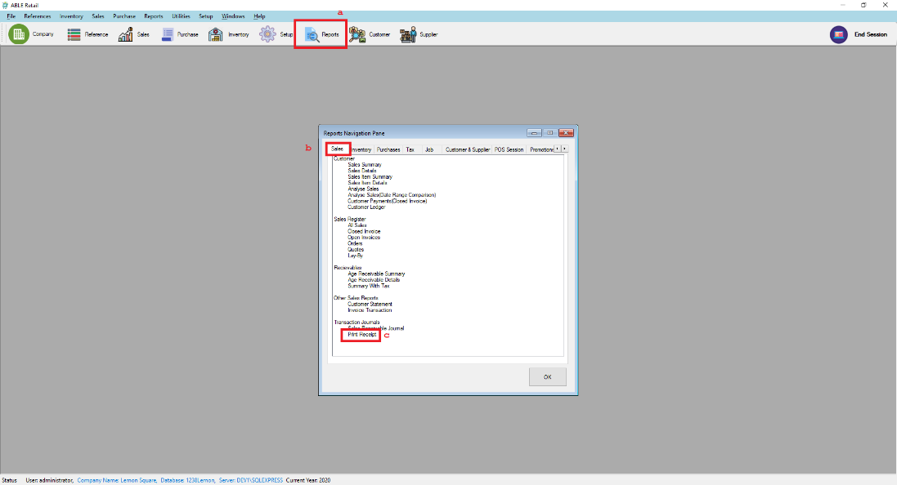
   1. Click **Reports** tool strip.
   2. Click **Sales** tab
   3. Click **Print Receipt** then click **OK.**
2. Print Sales Receipts form will be displayed. Change the dates to filter the transactions.
3. Check the transactions you want to prints then click generate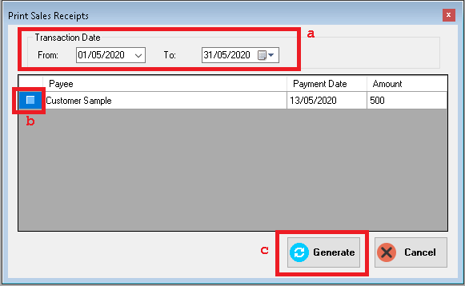

# Purchases

## Creating a supplier profile

1. Go to **Reference** and click **Supplier** or click **Supplier** in the tool strip.

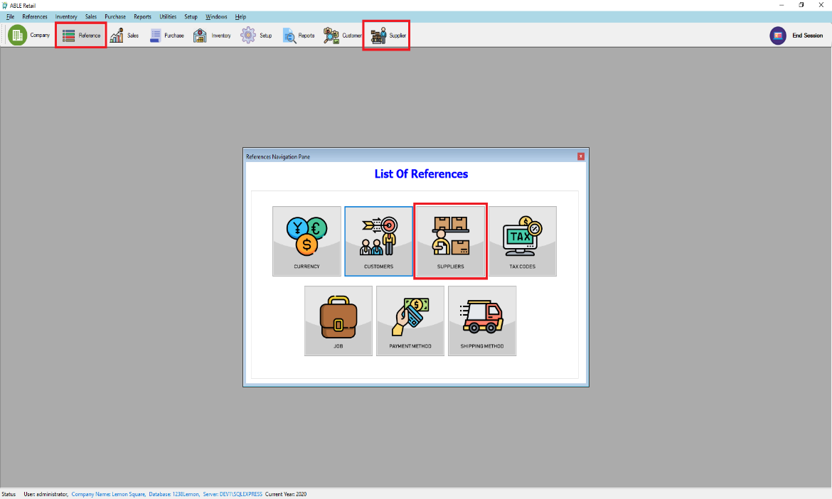

1. The Supplier list will be displayed. Click **ADD NEW**. 
2. The add Supplier form will be displayed. Enter your supplier information. If the company has more contact information. Select Address 2 from the location list and enter the additional contact information. A company can enter five contact information. 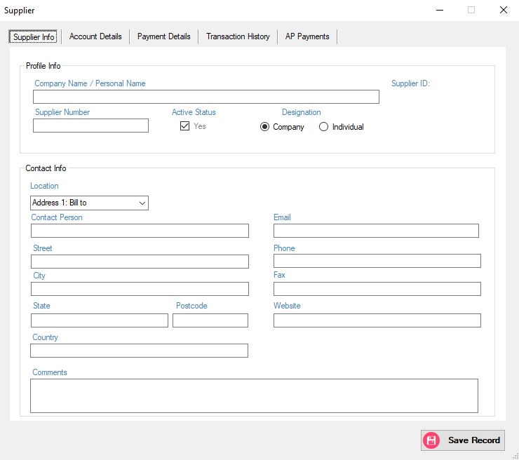
3. Go to Account Details Tab to enter your payment method will use to pay your supplier. Fill the necessary details then click **Save Record**.

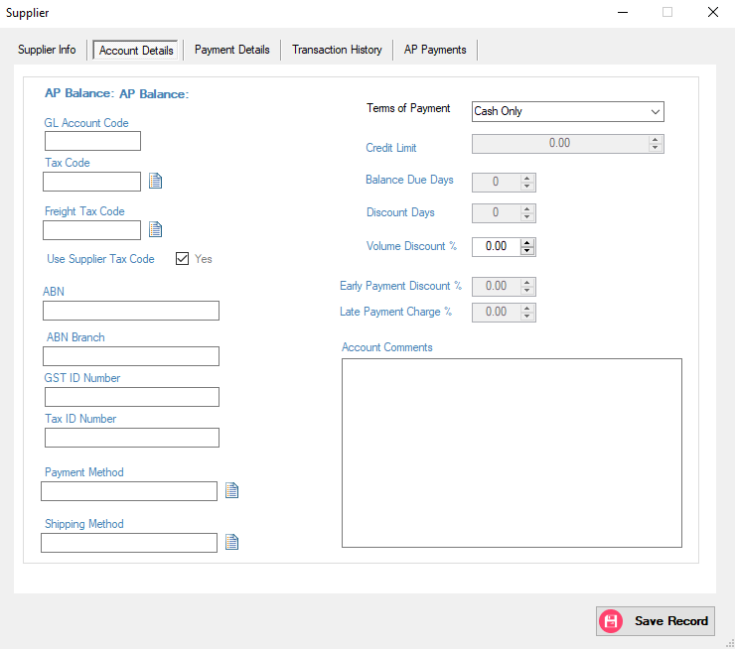

## Entering Purchases

1. Click **Purchases** in the tool strip to show the Sales Navigation Pane then click **Enter Purchases**.

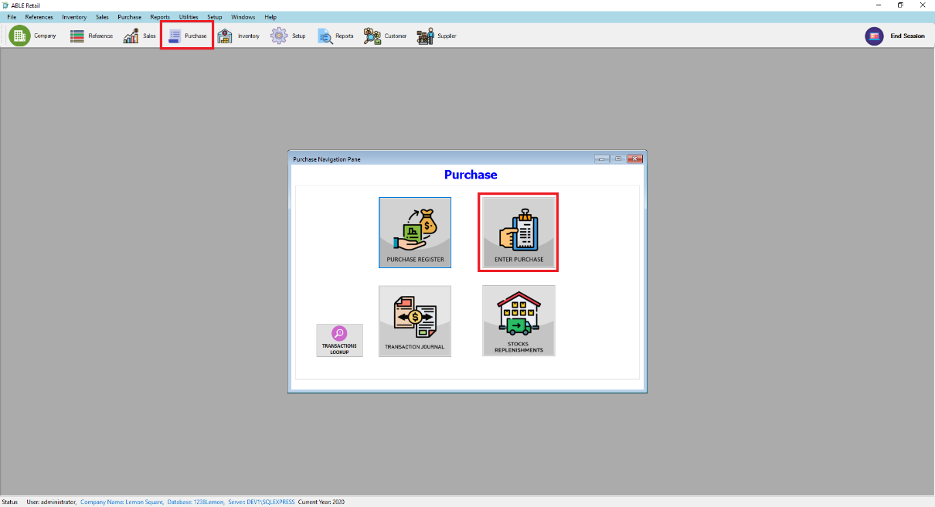

1. Enter Purchases form will be displayed.
2. Enter Supplier Details.

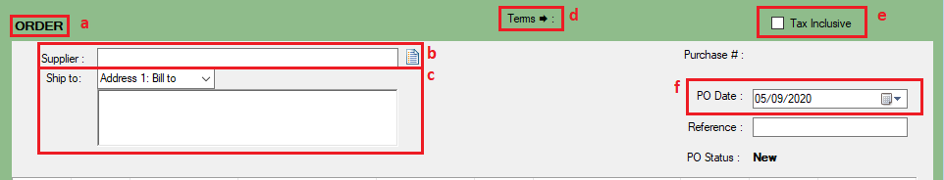

1. Type of Purchase is Order.
2. Click the icon in supplier field, the suppler profile lookup will appear and choose a supplier.
3. [Optional] Default Ship to address is Address 1
4. [Optional] Click to change term for this purchase. Default value will be the value entered in supplier account details.
5. [Optional] Check is purchase include tax.
6. [Optional] Transaction Date change when transaction occurred.
7. Entering transaction lines of the sale. The illustration below shows the field for **Item Layout.**

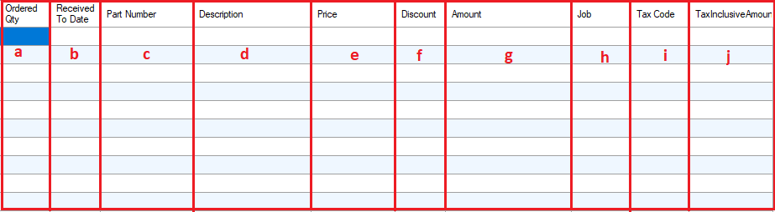

* 1. Quantity of item ordered from the supplier.
  2. It’s the receive date of an order.
  3. Type or Double click to open Item lookup. Select the item you need to order.
  4. Default is the description of the item. Can be change if you want.
  5. Default price is Base Selling Price. Can be change if desired.
  6. Percent of discount if desired to put a discount.
  7. Amount is Auto compute depending on price, Ship Qty., and discount.
  8. [Optional] Double click to display the Job Lookup to allocate the specific job.
  9. Select the tax code of the transaction line. Default is the tax code of the item.
  10. Tax Inclusive Amount of the Item Displayed

1. Click **Record** to save the purchase transaction or [Optional] Click **Save Recurring** if the transaction will be regularly recorded**.**

## Receive Items & Approve Purchase Order

1. After Recording the Purchase Order the user must approve the transaction made, click the **Approve PO** Button in the lower left corner of the form. 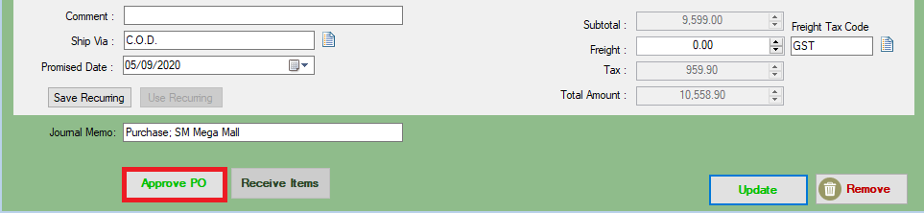
2. If the transaction is already Approve then you can received the item that has been ordered, click the **Received Items** Button in the lower left corner of the form. 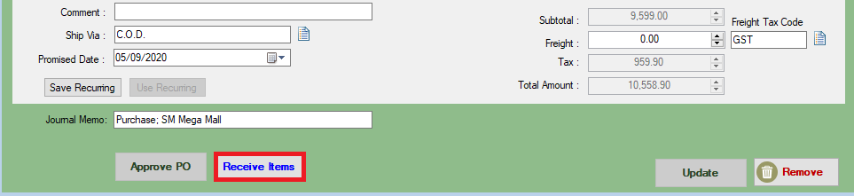
3. The Purchase Status will change to received item, click the record button to record all received item. 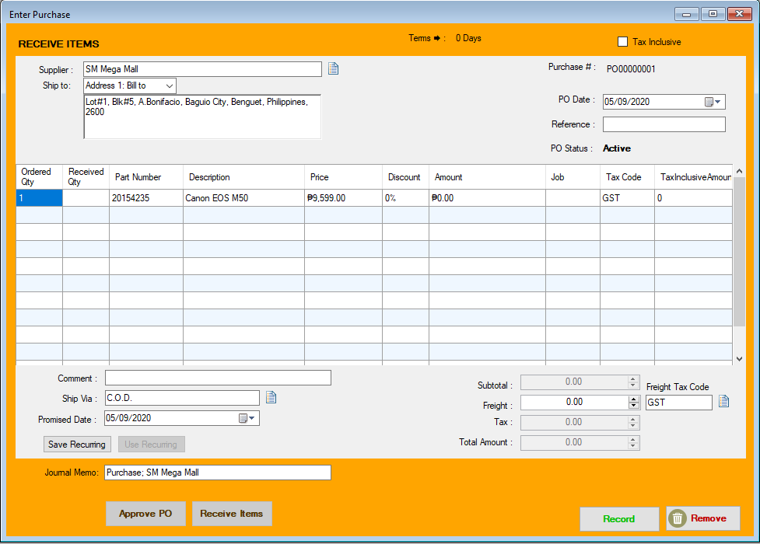
4. Received Item Dialogue Pop Up will show and fill up necessary data to complete transaction.

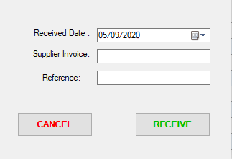

# Promotion & Loyalty

## Creating Loyalty Member

1. Click **Setup** in tool strip menu bar then click the **Loyalty Member.**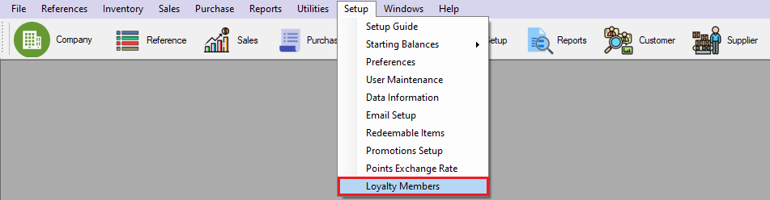
2. The Loyalty Member List Will Show and Click the **Add New** In the Lower Right corner to create a new loyalty member.
3. Fill up all fields to record credentials.

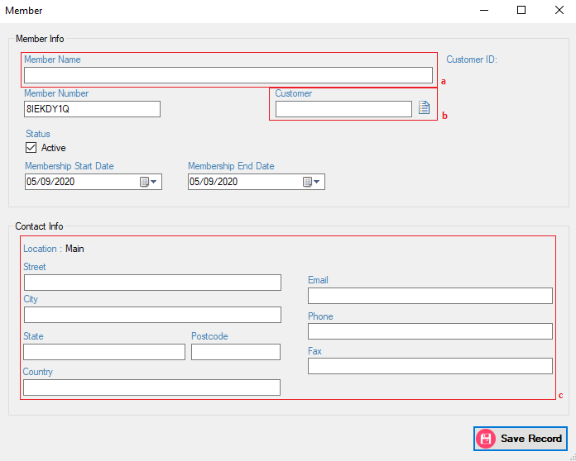

* + - 1. Enter the Name of the member.
      2. Click the icon in Customer field, the customer profile lookup will appear and choose a customer.
      3. [optional]Fill up Location Credential to record the address of the member.

## Creating Promos

1. Click The **Setup** Tool Strip menu Button the click the **Promotion Setup**.

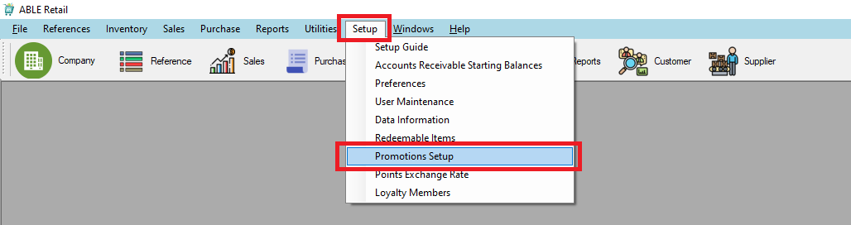

1. Promotion Setup Guide

2.1 Details Tab

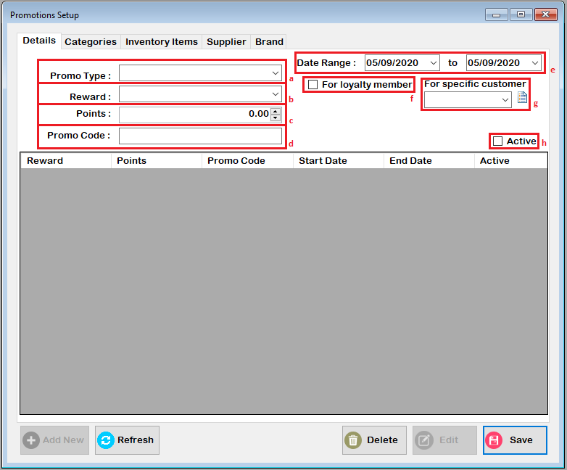

* 1. Select a Promotion Type

Default

Buy Quantity(x)

Buy Amount(x)

* 1. Rewards is dependent to the promotion type
     + 1. Default
* Point(x)
* Point(x)Percentage
* Point(x)Percentage Profit
  + - 1. Buy Quantity (X)

Free Product – Then select items that are going to be free if the item is in this promo.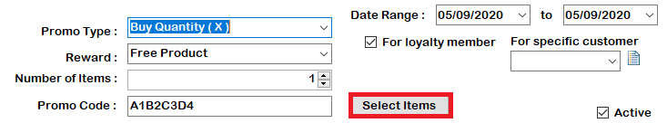

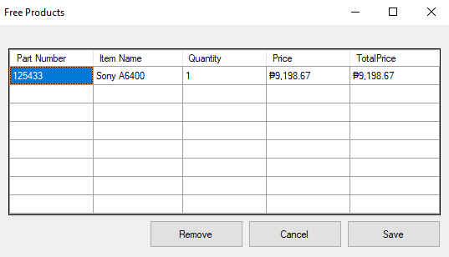

Double click the part number column and save to record free product items

Fixed (x) Discount

Percent Discount

Price(x)

* + - 1. Buy Amount (x)
         1. Percentage (x) Discount From List
  1. This also depends on the selected Promotion and Rewards selected.
     + 1. Promotion Type is Default and reward is “points (x)”  
          this field will turn in points field
       2. Promotion Type is Default and reward “Points (X) percentage” this field will turn in Points % field same with the Points (X) percentage profit reward.
       3. Promotion Type is Buy Quantity(x) and reward is “Free Product” this field will be number of items that are free.
       4. Promotion Type is Buy Quantity(x) and reward is “Fixed (X) Discount” this field will be discount amount.
       5. Promotion Type is Buy Quantity(x) and reward is “Percentage Discount” this field will be discount percent.
       6. Promotion Type is Buy Quantity(x) and reward is “Price (X)” this field will be Price.
       7. Promotion Type is Buy Amount (X) and reward is “Percentage (X) Discount From List” this field will be Discount percent.
  2. This will indicate the promo code of the promo.
  3. select the date range of the promo
  4. check this if this promo is for loyalty member only
  5. specify a customer for this promo
  6. Check this to specify if the promo is active or inactive.
  7. Category Tab

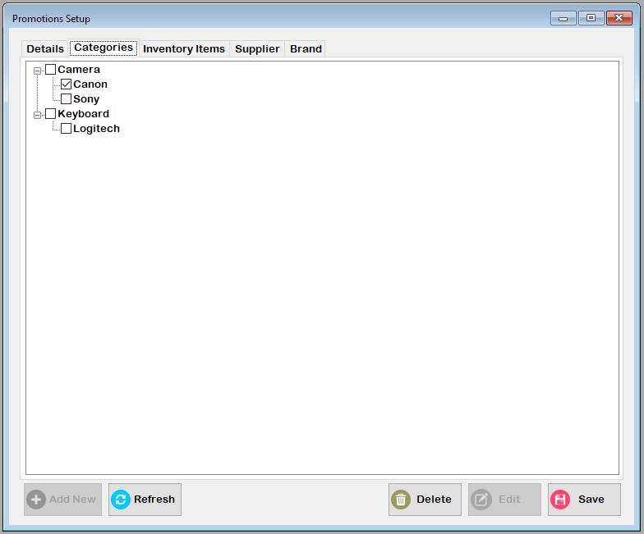

* + - Select the category that will be applied in this promo
  1. Inventory Items Tab

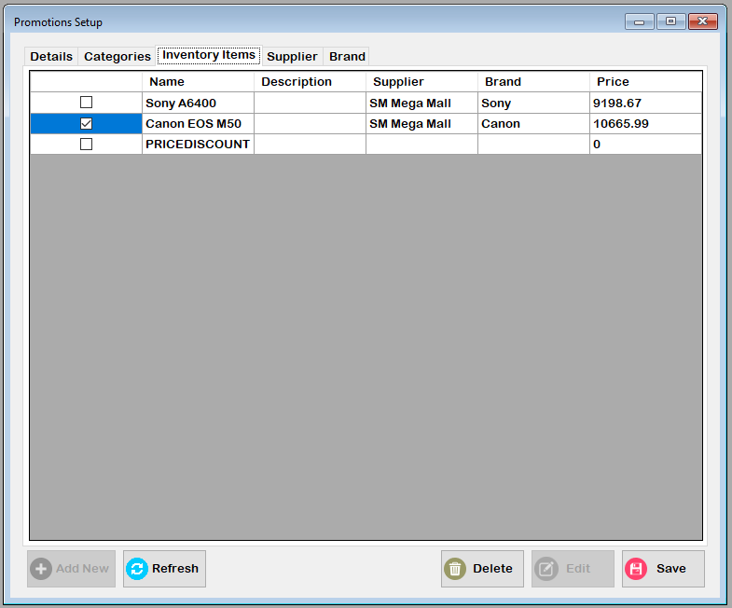

* + - Select the items that is applied in this promo
  1. Supplier Tab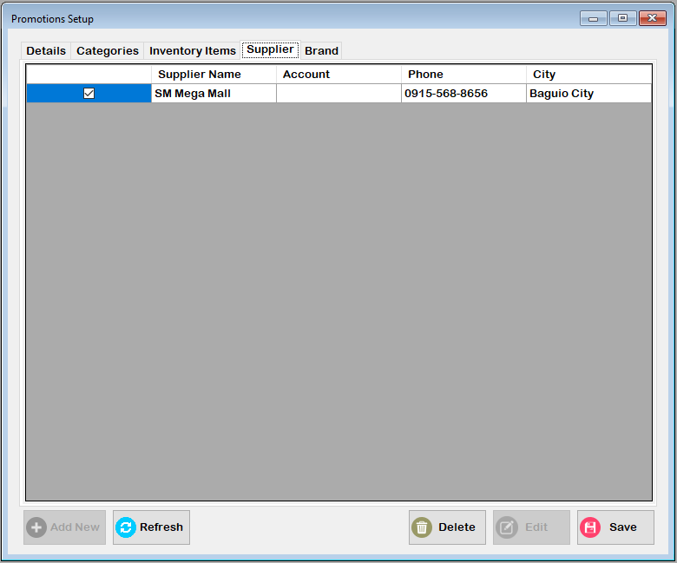

- Select the supplier that is applied in this promo

* 1. Brand Tab

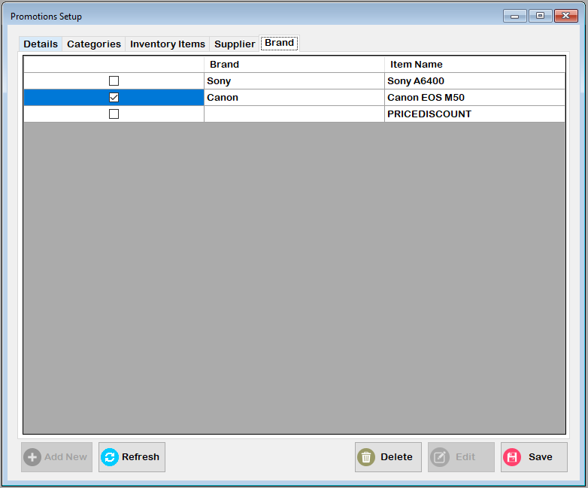

* + - Select the brand that is applied in this promo

1. Click The Save Button to record all applied in this promo.

## Points Exchange Rate

* + - 1. Click Setup in tool strip menu bar then click the Points Exchange Rate.

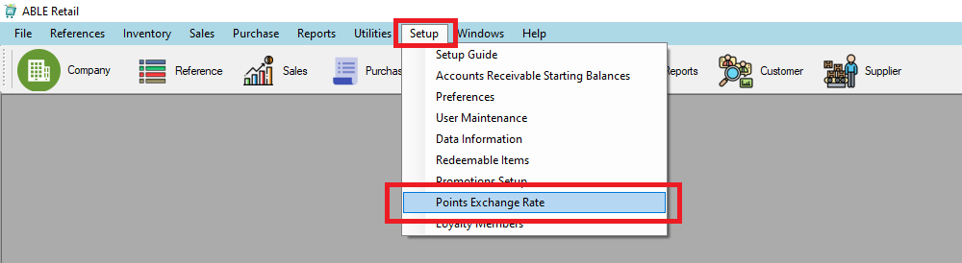

* + - 1. Point Exchange Rate Guide

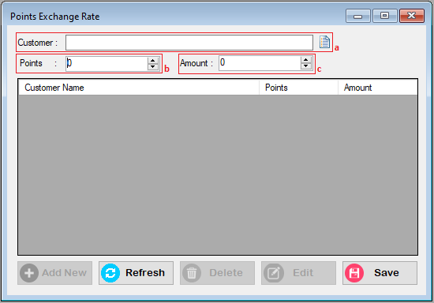

* + - * 1. Click the icon in Customer field, the customer profile lookup will appear and choose a customer.
        2. Specify points to convert in amount
        3. Specify the amount per points

# Transactions

## Finding Transactions

### Using Transaction Lookup

### Using Sales Register

* 1. Go to **Sales Navigation Pane** and click **Sales Register**. The Sales Register will be displayed.
  2. Filter your search using the **Search by** function. For example, you can change the drop down box to search for a specific customer, adjust the date range for more specific result. You can view the transaction detail by double clicking the selected transaction.

### Using Purchase Register

1. Go to **Purchase Navigation Pane** and click **Purchase Register**. The Purchase Register will be displayed.
2. Filter your search using the **Search by** function. For example, you can change the drop down box to search for a specific supplier, adjust the date range for more specific result. You can view the transaction detail by double clicking the selected transaction.

### Using Item Register

1. Go to **Inventory Navigation Pane** and click **Item Register**. The Purchase Register will be displayed.
2. Filter your search using the **Search by** function. For example, you can change the drop down box to search for a specific item, adjust the date range for more specific result. You can view the transaction detail by double clicking the selected transaction.

## Changing or Deleting Transaction

### Changing Transaction

Only **Order** transactions can be deleted.

1. Go to Sales Register and go to **Order** tab.
2. Search for the transaction to be edited using the filters.
3. Double click the transaction to be edited.
4. Edit the details you want to change and click **Update.**

### Deleting Transaction

Only Quote transactions can be deleted.

1. Go to Sales Register and go to **Quotes** tab.
2. Search for the transaction to be deleted using the filters.
3. Select the transaction and click **Delete**.

## Reversing Transaction

Only **Invoice** transactions can be deleted.

1. Go to Sales Register and go to **Invoice** tab.
2. Search for the transaction to be edited using the filters.
3. Double click the transaction to be edited.
4. Edit the details you want to change and click **Reverse.**

## Recurring Transaction

Recurring transactions are transaction you record regularly.

### To create new recurring transaction

1. Enter Transaction Detail in a Transaction window. For example, Sales Transaction.
2. Click **Save Recurring.**
3. Edit Recurring Schedule, Such as Frequency of transaction, Notification schedule.
4. Click **Save.**

### To use existing transaction as Recurring

1. Find the transaction and load the transaction. see 7.1 Finding Transaction.
2. Click **Save Recurring.**
3. Edit Recurring Schedule, Such as Frequency of transaction, Notification schedule.
4. Click **Save.**

### Recording Recurring transaction

1. Go to **To Do List** in **Utilities**.
2. Select the appropriate Recurring tab.

# Reports

To display and print report.

1. Click the **Reports** tool strip. 
2. The **Report Navigation Pane** will be displayed. Search for the report of the desired print then click **OK**.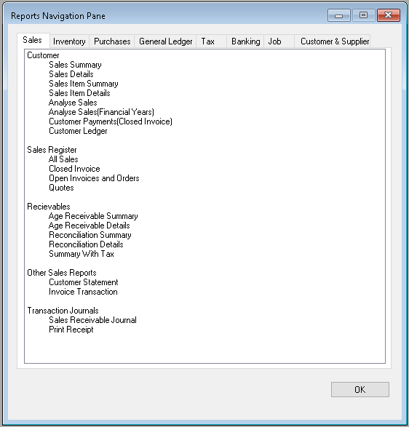
3. A Report Customizer will be displayed. Filter the data you want to be displayed, For example, transaction date, sales status. Then click **Print**.
4. [Optional] Display the data before printing or export as an excel file.

# Sessions

## Starting a Session

### Starting a new session to create transactions.

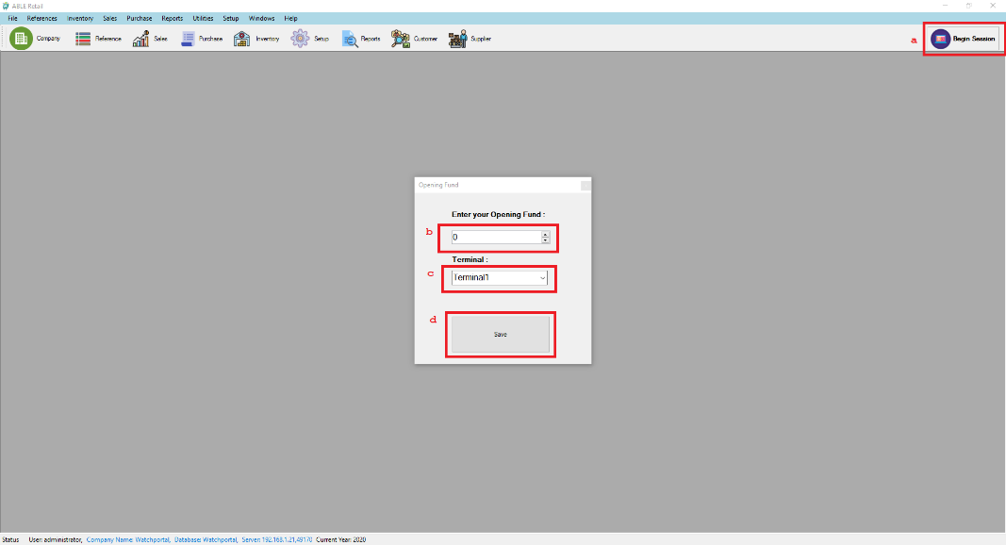

1. Click **Begin Session**.
2. Opening Fund in the cash drawer.
3. Select the terminal to use.
4. Save to start the session.

### Continuing existing session.

1. Click **Begin Session**.

*A message box will show if there is a terminal with an open session with no user.

1. Click **Begin Session**.
2. Chose **Yes** to show list of existing sessions. 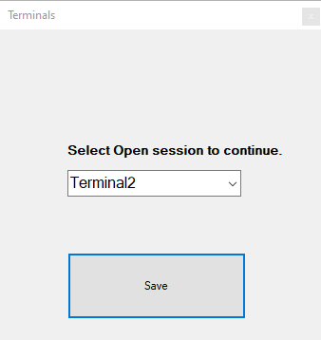
3. Select the terminal to use.
4. Save to continue the session.

## Ending a Session

Ending a session at the end of shift.

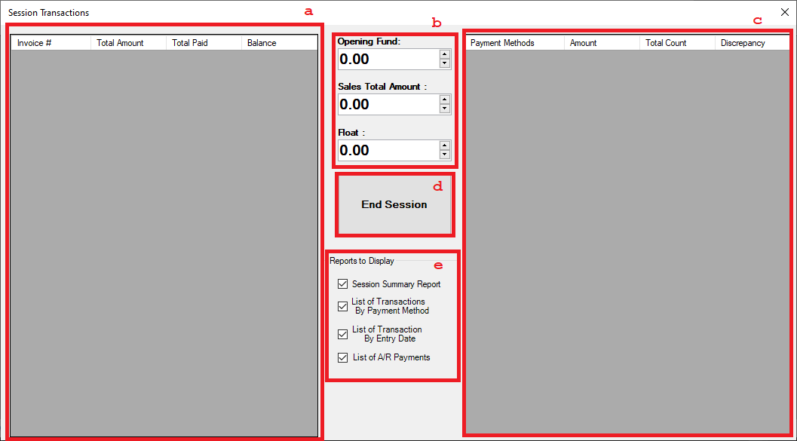

1. Display all the sale in the session.
2. Shows the opening fund, Total Sales, Float. In the session.
3. Summarize the sales of the sale per payment method.

Note: Cannot end the session without entering the total count per payment method.

1. **End Session**
2. Print the Report at the end of sale. Uncheck the back to not display the report.

## Session Manager

Manage terminals with running session that are forcefully closed.

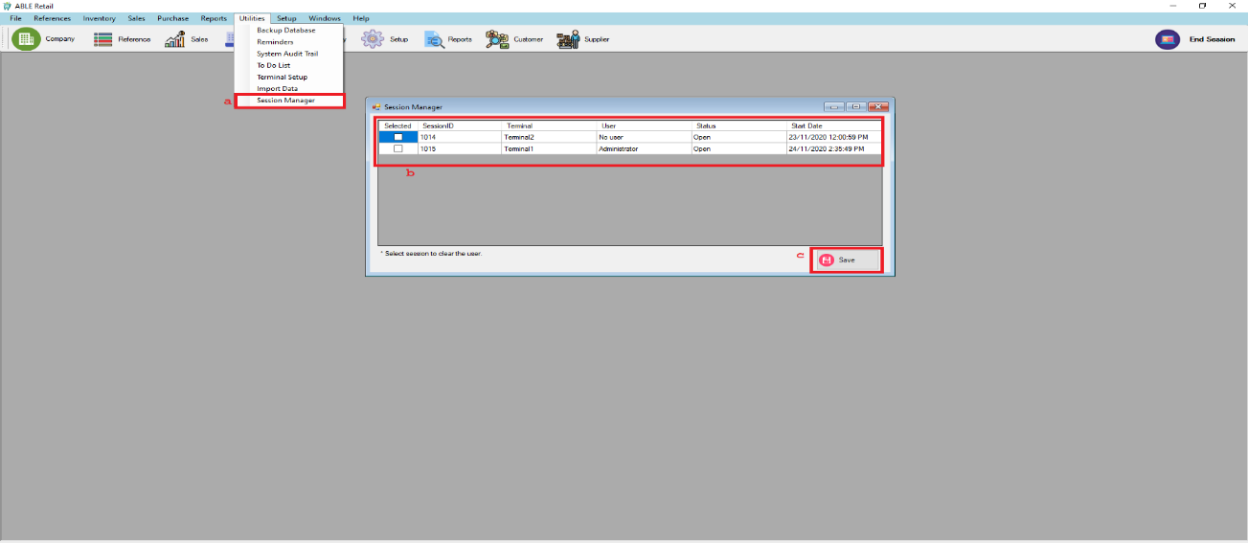

* + - 1. Under **Utilities.** Select **Session Manager.**
      2. Select the session by checking in the selected column.
      3. Save.

# Backup Database

To save your existing database and to restore database for future purposes.

1. Click the utilities under the main tool strip.

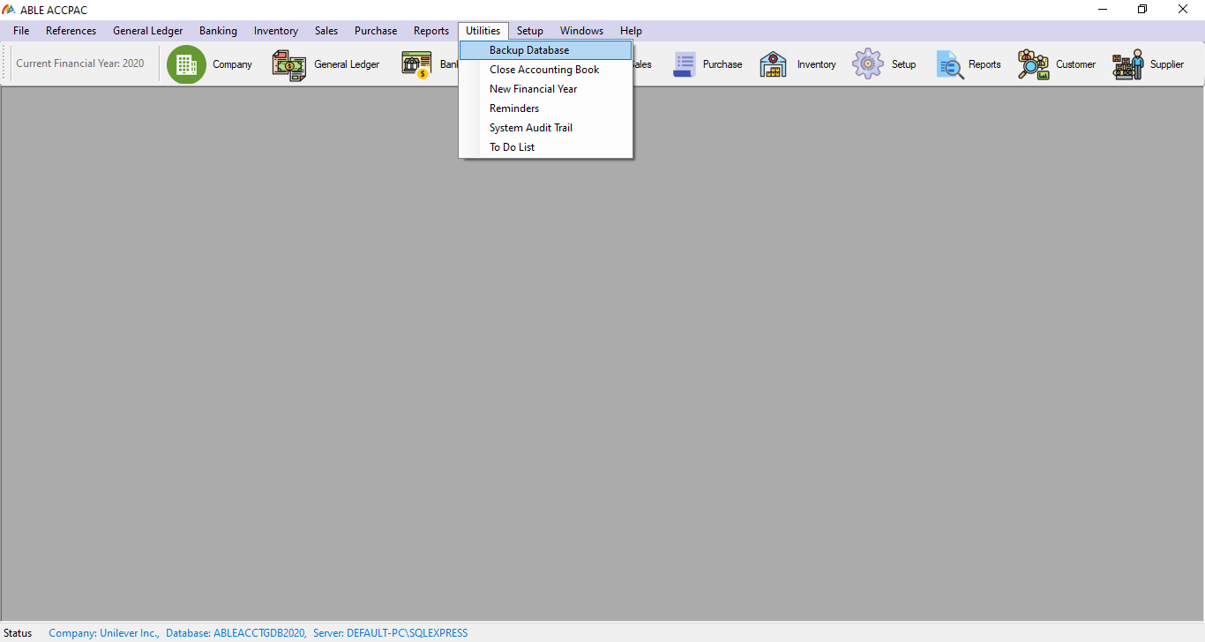

Then click the backup database to save your existing database

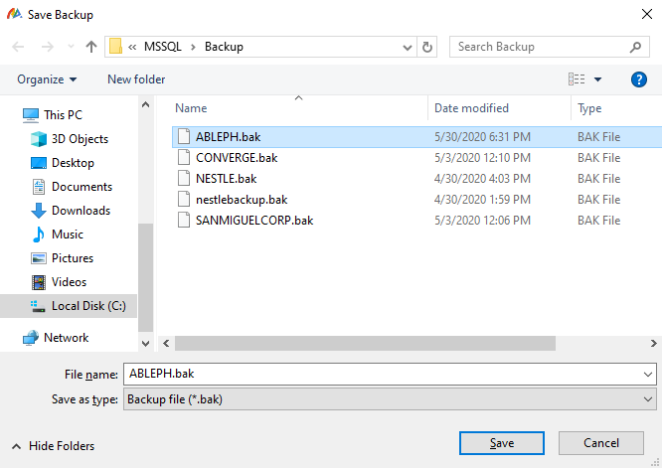

Click the save button.

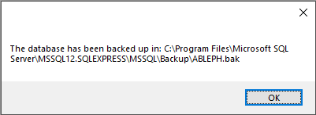

This will appear if the database file has been successfully saved.

Note: You should specify that the folder you are saving is rooted in the SQL server folder under your program files directly to the backup folder where the SQL management tools backup function is allocating your database file or your .bak file. See example in the picture.

## Auto Backup Database Tool

* + - This tool helps you to backup all existing database on your current server.

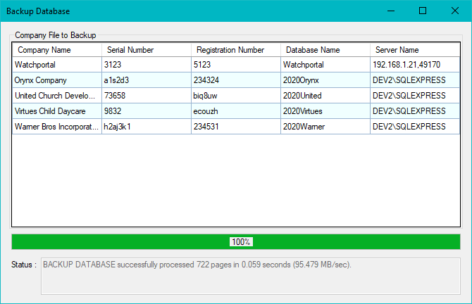

Note: -Make sure that all database are in your server

-Saving the .bak file in a specified folder should have an Authenticated user permission e.g. Right click the specified folder then go to the security tab. See example below.

-Make sure that the added authenticated user has a full control on the specified folder. 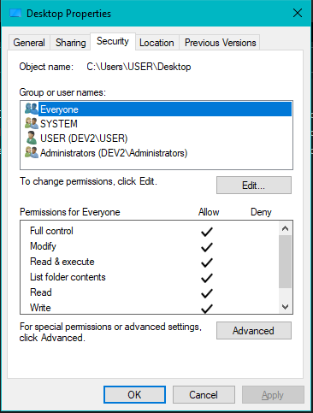

# SQL Restore DB

To Restore Existing DB and to use for future purposes.

1. First you should specify the server authentication and your server name in your SQL management tools.

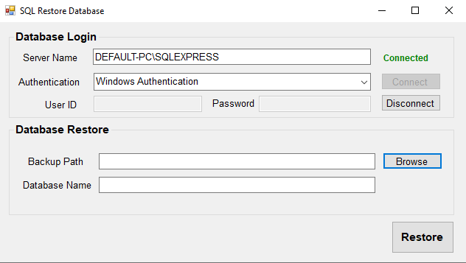

Then hit the connect button.

1. After connecting you browse the database file or the .bak file that has been save in the SQL server folder under your program files directly to the backup folder where the SQL management tools backup function is allocating your database file.

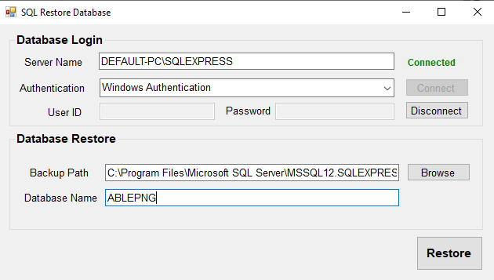

Then name your database to the company you want which you will create later on in the company profile editor. Then click the restore button

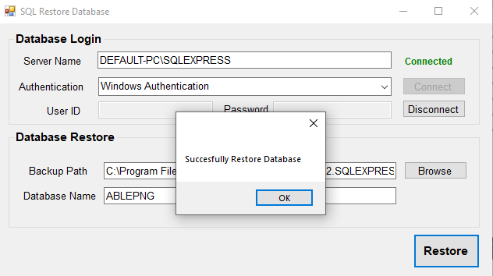

# Company Profile Editor

To Save and to Restore company file created by the user

1. Click **Add New** button to create new company file

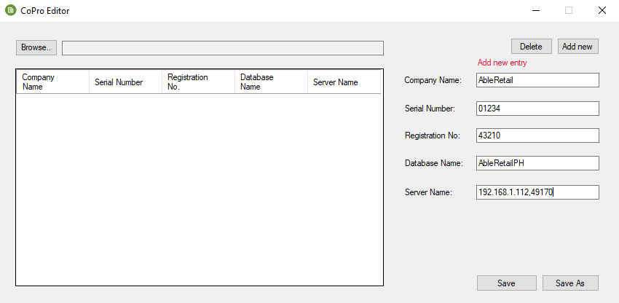

1. And then Click **Save As** to create the file for the company, which will prompt the user to name the file. 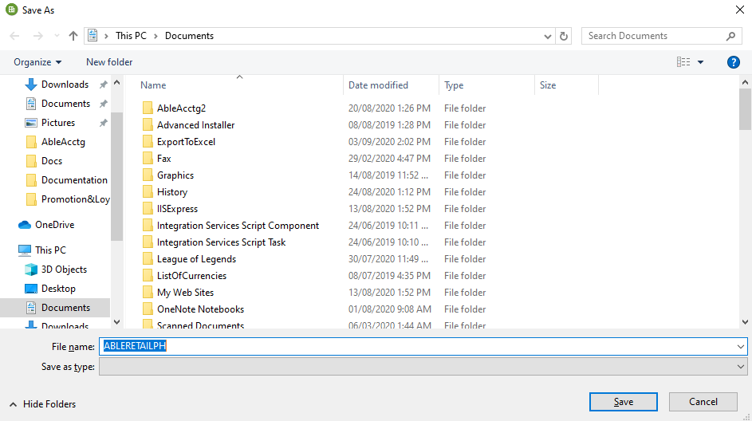
   * + Company file created successfully

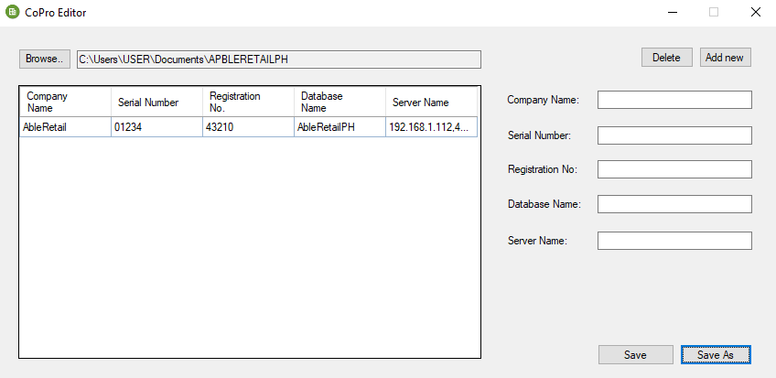

1. Restoring Company File
   * + Click the Browser Button to select the Created company profile which was saved as a file in your computer. 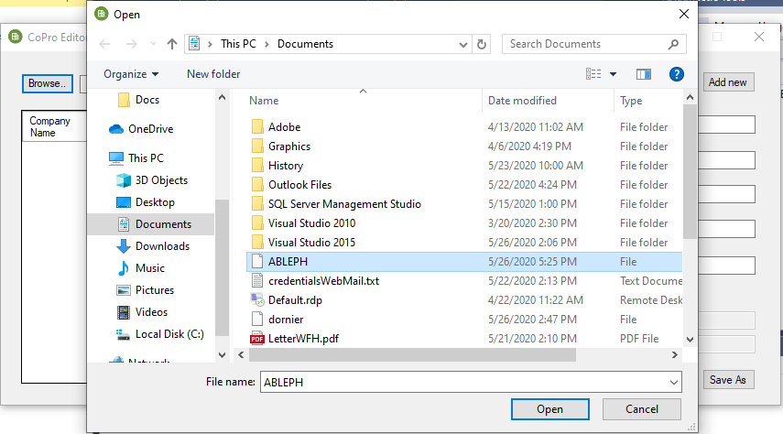

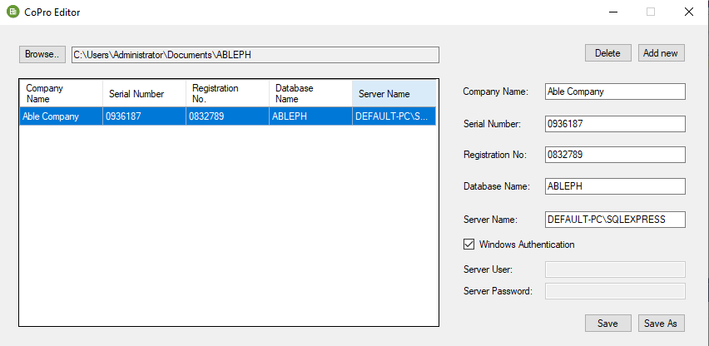

# Journal Export Tool

This Form allows you to export journals from **able retail** to **able accounting**

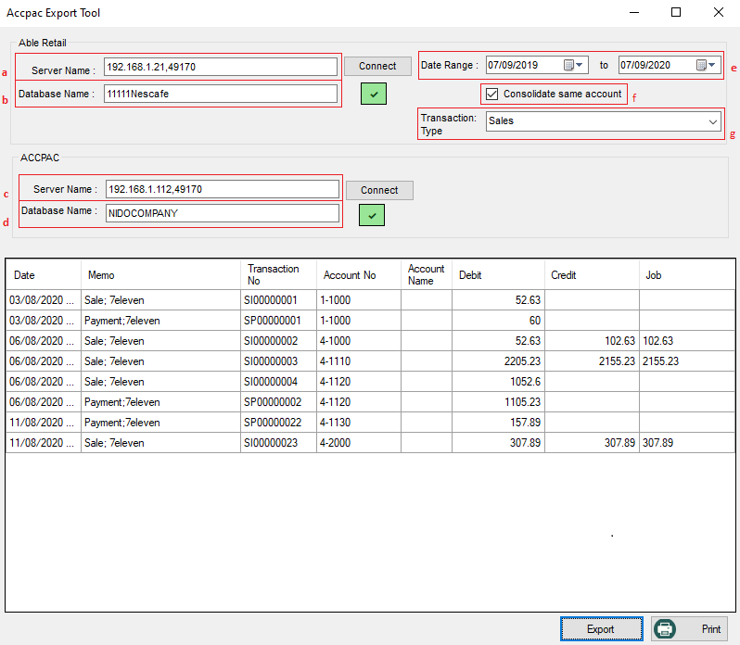

* + - 1. Insert the Able Retail server name and the data base name and check for connection to the database.

1. This field specify the **server name** used in able retail system.
2. This field specify **database name** to be used on exporting the data of journal entries to able accounting database.
   * + 1. Insert the AccPacc server name and the data base name and check for connection to the database.
3. This field specify the **server name** used in able accounting system.
4. This field specify the **database name** to be exported from able retail.
   * + 1. Set the data range of the transaction to be exported and other filters.
5. Select the Date Range of the transaction date of the sales, purchase, or both.
6. Check if all accounts are the same to consolidate the transactions.
7. Select the transaction you want to export, such as Sales, Purchase or Both.
   * + 1. Then Click the Export Button on lower right corner of the form to export the data displayed on the data grid. You can also print this data by clicking the print button on the lower right corner of the form

# Kitchen Display

Display the orders to the kitchen and to update the status of the orders.

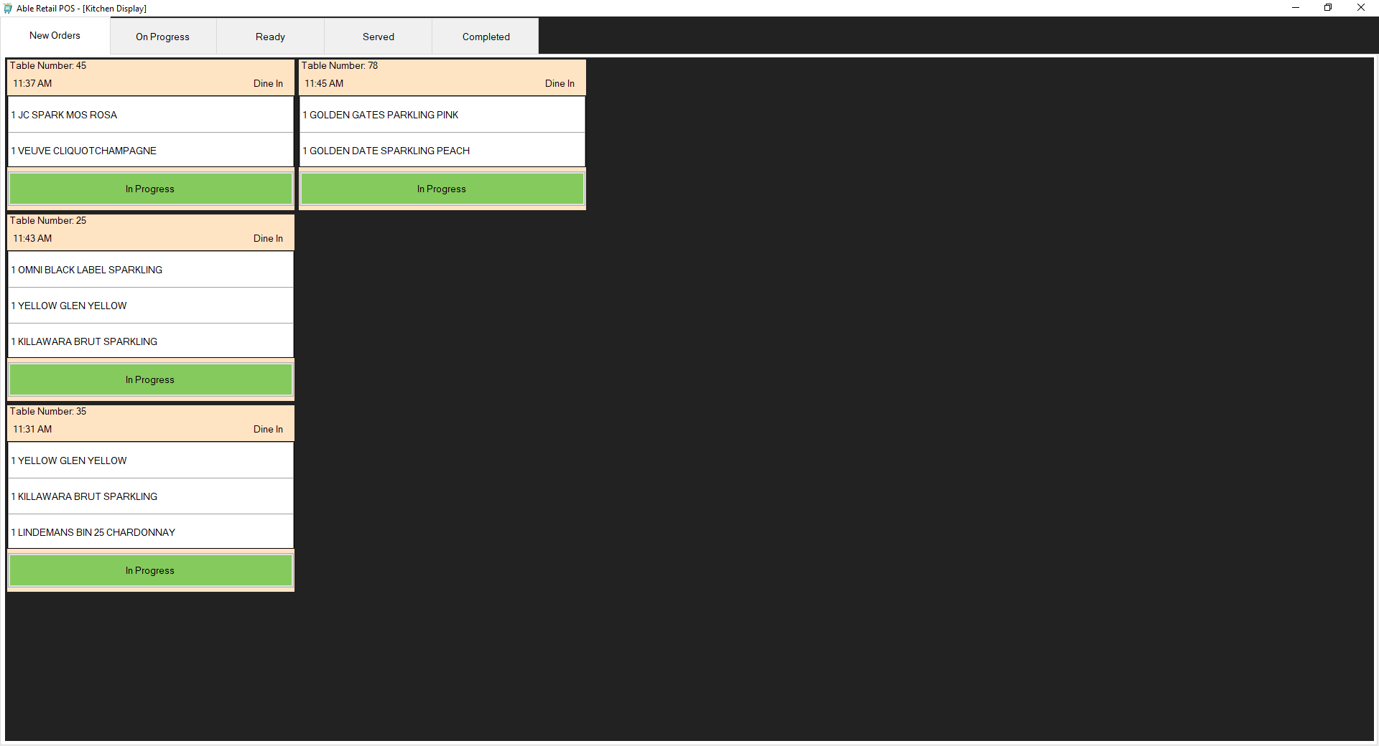

**New Orders**

This tab displays new orders that are not yet being prepared. It also refreshes every minute. Click the **In Progress** button **if** the order is going to be prepared.

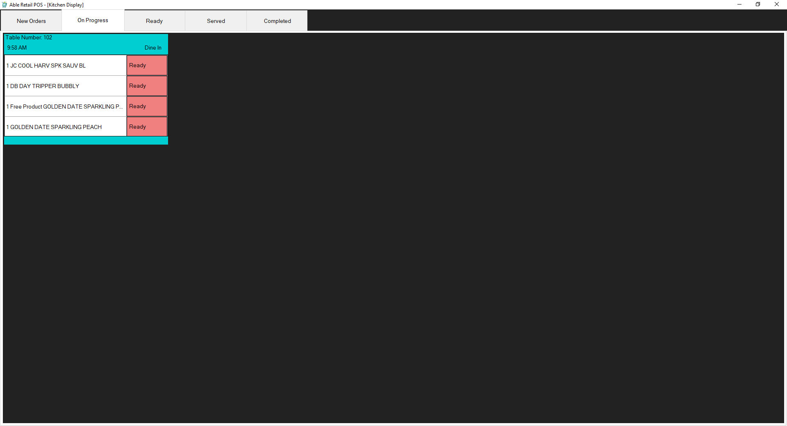

**On Progress**

Displays the all the ordered items per table. Click **Ready** if the item is prepared and ready to be served.

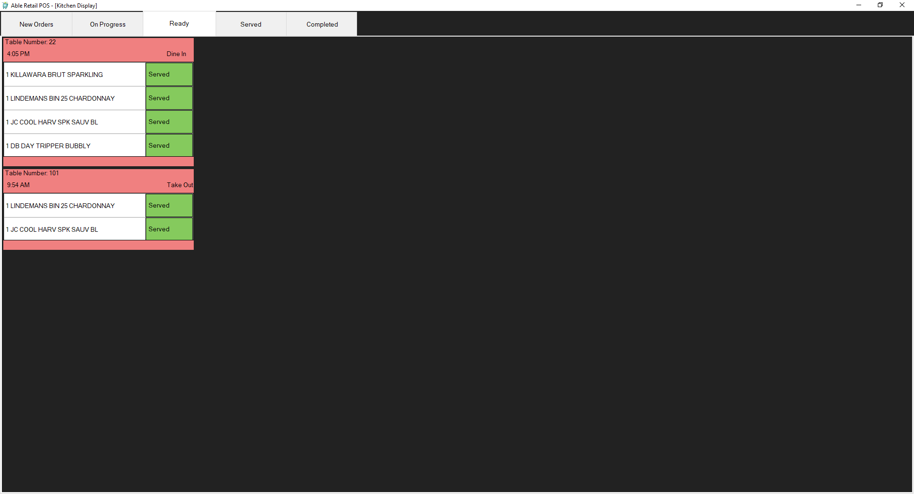

**Ready**

Displays the items that is ready and waiting to be served. Click **Served** if the item is served to the customer.

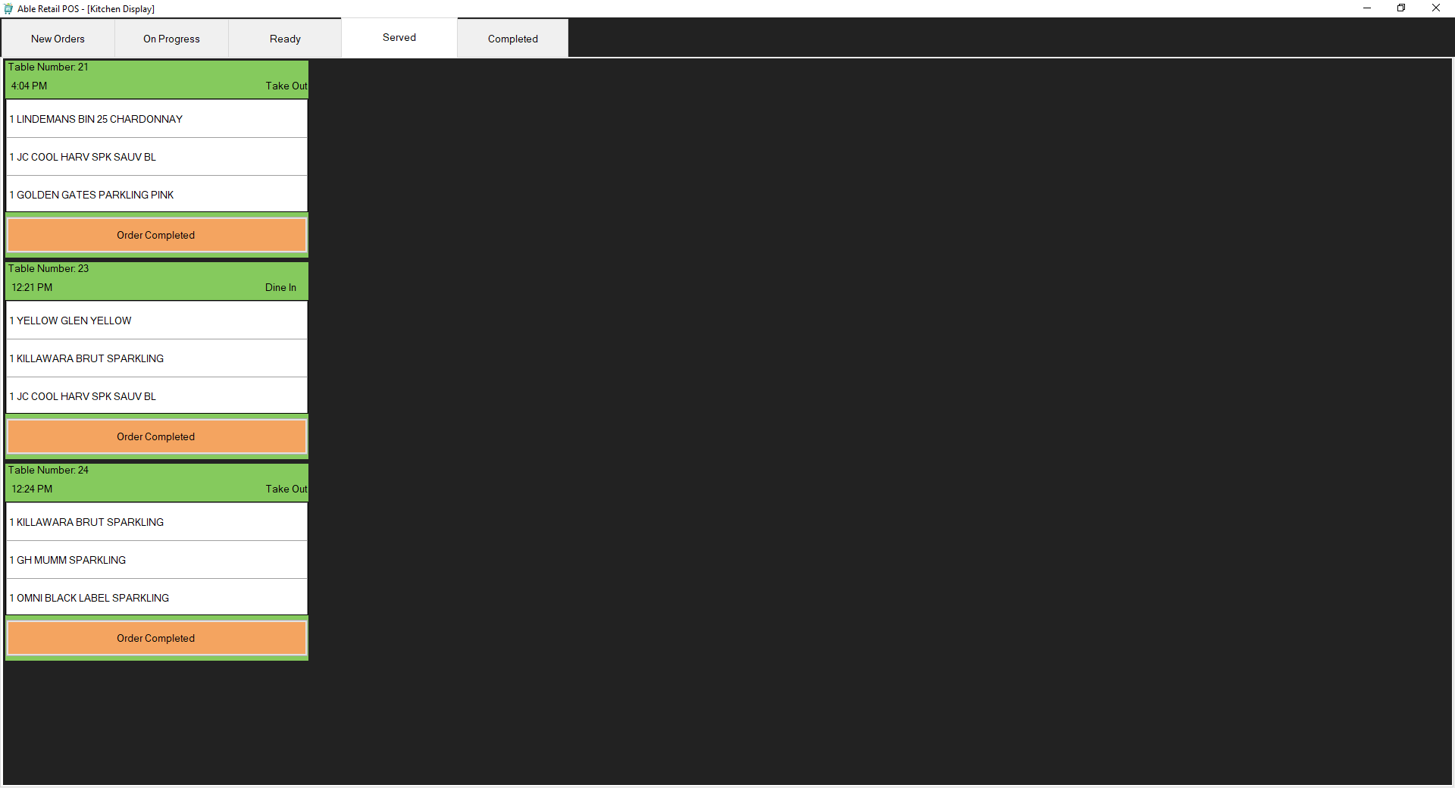

**Served**

Display the item that is served and the Order Completed button will be displayed if all the item of that order is served. Click the Order Completed button to update the order status.

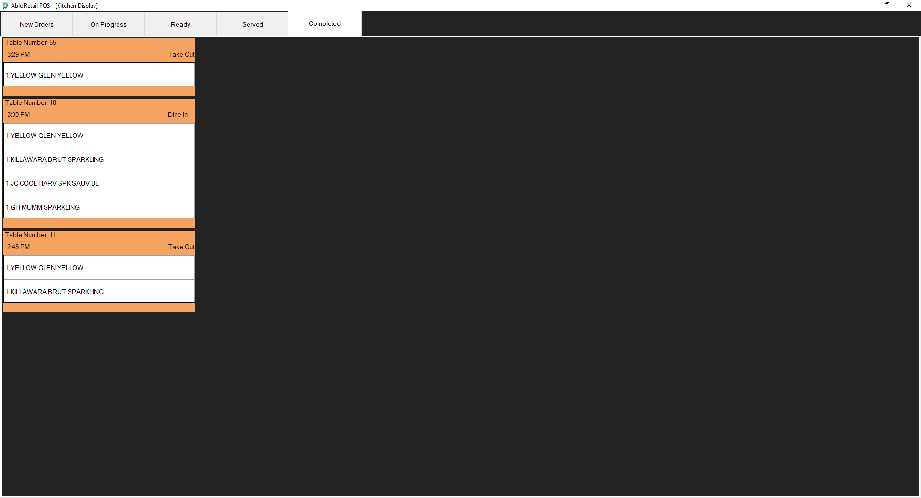

**Completed**

Display the orders that is completed and all the item that is ordered by the customer is served to them.